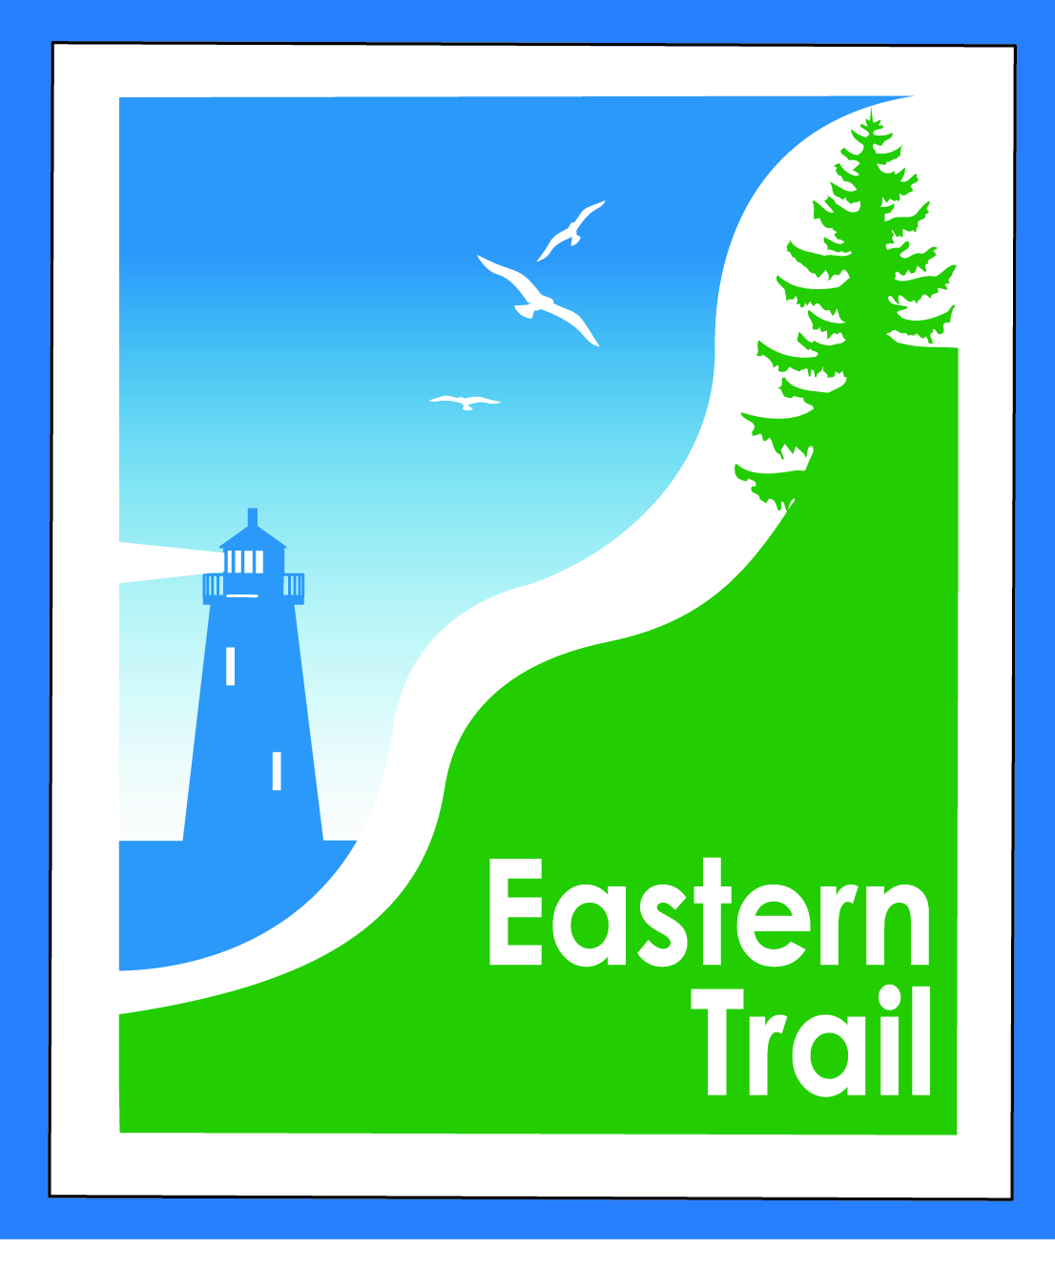
ETMD Board of Directors Agenda
Kennebunk Town Hall - Third Floor Conference Rm – December 11, 2019 - 8:30 – 10:30 a.m.

- Welcome & Introductions – 15 min
- Minutes of November 13, 2019 – attached - needs vote - 5 min
- Financial – 15 min
  - November report – attached - needs vote – Carole, Val
  - Dues status – Carole
- Operations – 30 min
  - Reports from ETA & Municipalities – all
  - ETMD Operational Updates – Carole
  - ETA Updates – Nancy
- Ongoing / Proposed Projects - 45 min
  - Close the Gap - Scarborough – 019386.00 – Carole
  - Over the River – Saco-Biddeford connection – Greg, Ryan, Carole
  - Blazing the Trail South - Kennebunk – South Berwick –- Carole, Bryan, Marianne, Tom

- Outreach & Events – 5 min
  - Upcoming ETA / ETMD events – Carole, Nancy

- Other Business? – 5 min
- Next Meeting – January 8, 2020
- Adjourn

