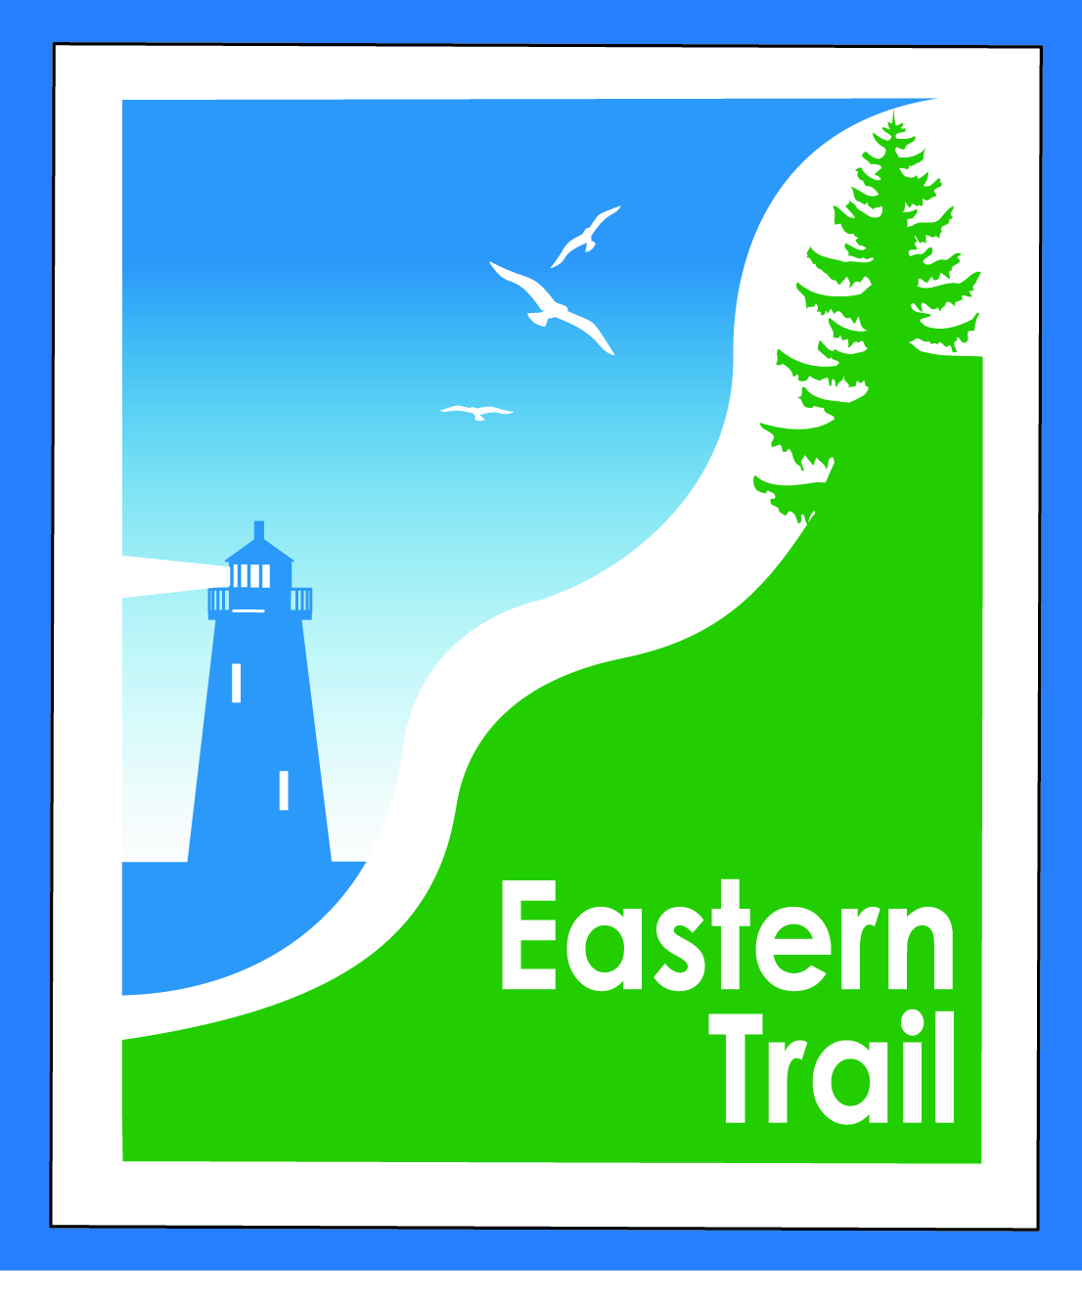

ETMD Board of Directors – Agenda
Kennebunk Town Hall - Third Floor Conference Rm – October 14, 2015 - 8:30 – 10:30 a.m.

- Introductions – 3 min
  - Welcome Kennebunk DPW Director and ETMD Representative – Eric LaBelle

- Minutes of September 9, 2015 (included) – needs vote - 5 min

- Current Financial Report – Val/Carole (to be sent by Tuesday) – needs vote – 5 min

- ETMD Priorities - 90 min
  - Management Policies & Procedures
    - Trail Maintenance/Repairs/Municipal Reports – Carole
      - Maintenance Status Report (to follow by Tuesday)
      - Reports from Municipalities (includes status on new projects - Kennebunk, OOB, Scarborough, Wells & Unitil re CLA)
      - Discussion: potential Parks & Rec meeting (similar to the DPW mtg held in May)
      - Signs – directional and “thank you Unitil” – Bob
    - Review of ETMD By Laws & Policies – (see ink in email) - Bill
    - Future ET planning – Carole
      - Review of current office space – growth considerations
      - Outreach & funding

- Summary and Events – 15 min - Carole
    - ? on ED Report (to be sent by Tuesday)
    - Report on ETMD 2015 events, estimate on 2016 events (to be sent by Tuesday)

- Other Business - 2 min – issues? Concerns

- Next Meeting – November 11, 2015

- Adjourn

