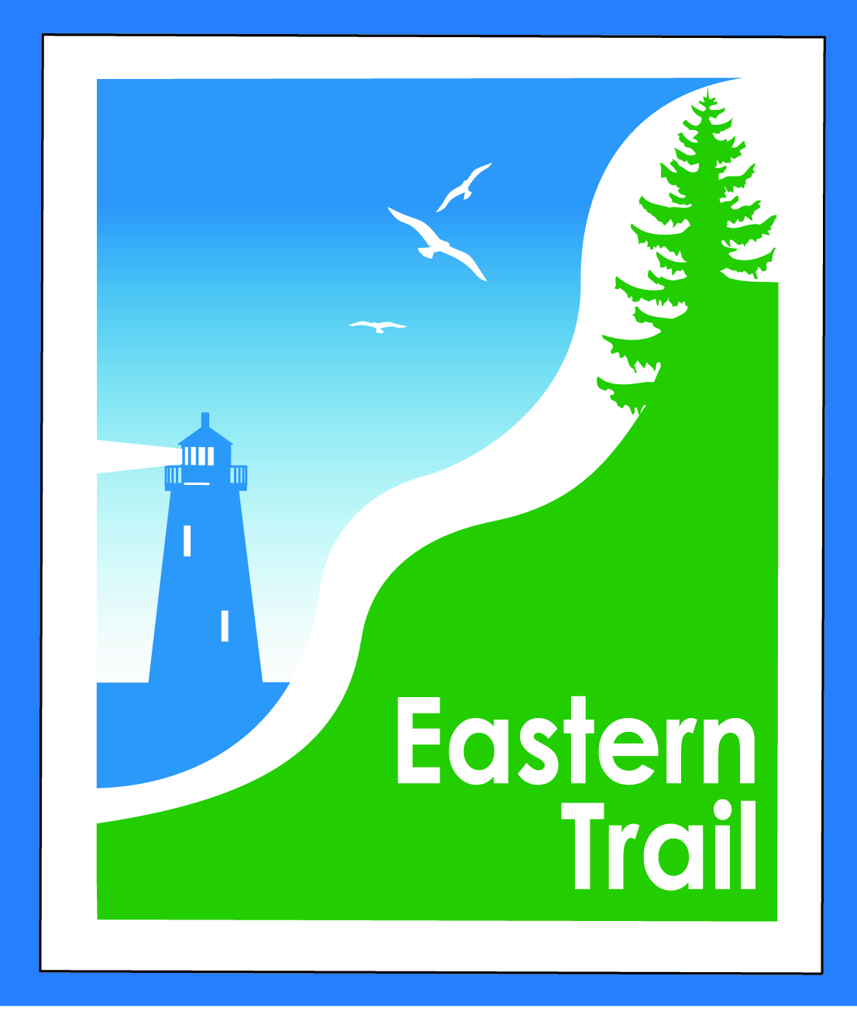

ETMD Board of Directors – REVISED, REVISED Agenda
Kennebunk Town Hall - Third Floor Conference Rm – October 12, 2016 - 8:30 – 10:30 a.m.
- Minutes of September 14, 2016 (to follow) needs vote - 2 min
- Financial Report – Carole, Val (September, to follow) – needs vote – 3 min
- ETMD Priorities 60 min
  - Trail Operations/Maintenance priorities
    - Update: Arundel: Ban Billy from trail – dog bite incidents
    - Bollards – Status from OOB re relocation of Milliken Mills Road bollards
  - Dues Status: All in
  - Response to concerned Scarborough citizen re “rules” for “lanes” to use in walking/biking on the ET (info presented at meeting)
  - Maine DOT – review application process and funding amounts (update presented at meeting)
  - Annual Audit & 990: Due November 15th – in process
- Ongoing / Proposed Projects: 50 min
  - ET Scarborough Marsh - Discussion re IFW plans for cottontail rabbit management (update presented at meeting)
    - ETMD position statement
  - Scarborough – 019386.00 Bill R, Carole B (grassroots)
  - Status Kennebunk – Wells – Marianne, Eric
  - Reports from Municipalities
- Outreach, amenities & Events – Carole/Bob H
    - Report on ETMD 2016 booked events
- Other Business – issues? Concerns? 5 min
- Next Meeting – November 9, 2016
- Adjourn

