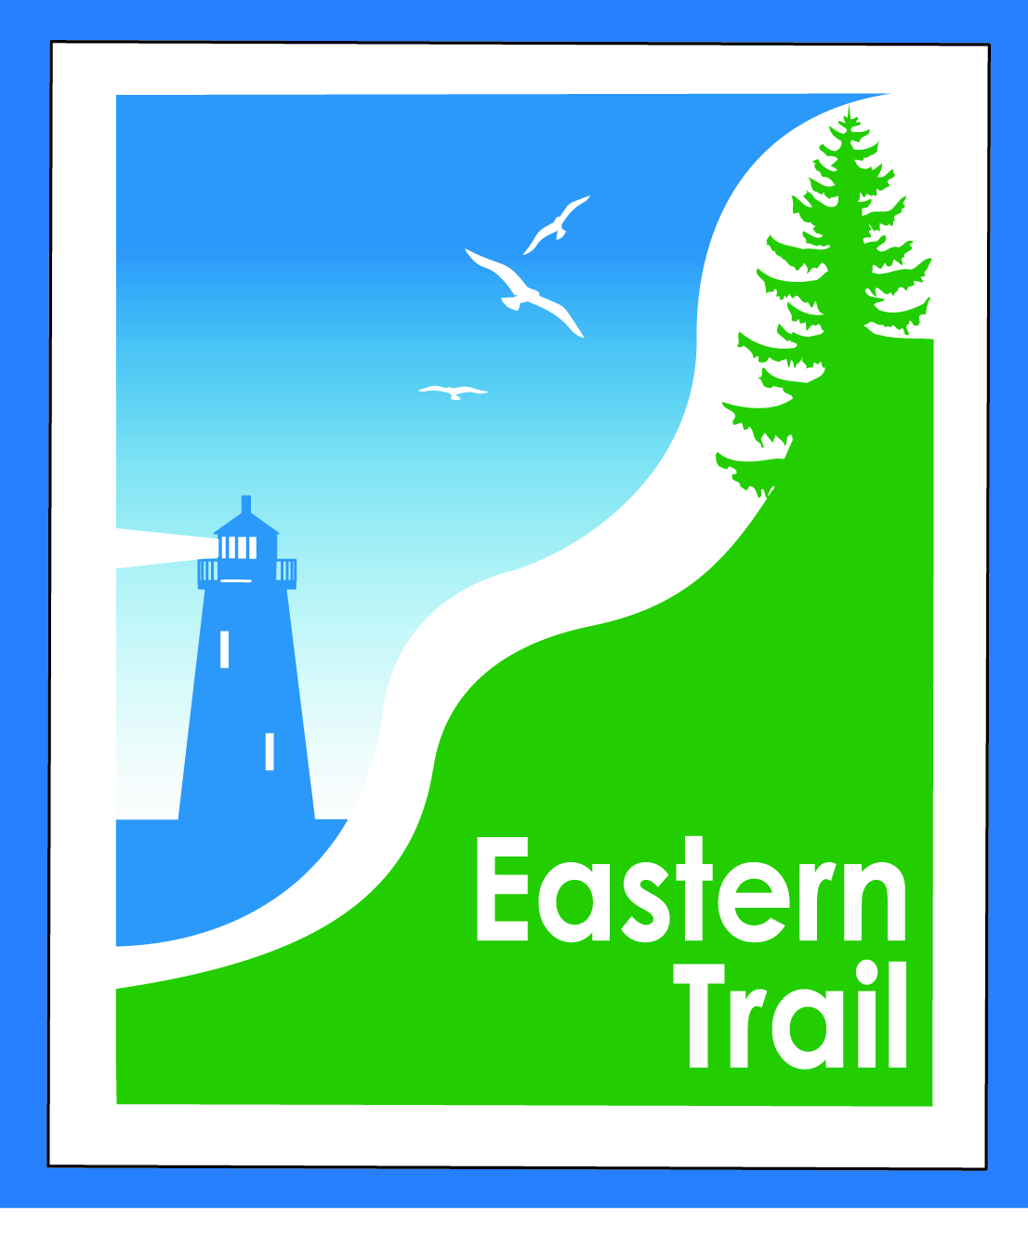

ETMD Board of Directors – Minutes -- October 11, 2017
Attendees:
    - Officers: Eric Labelle, VP
    - Trustees: Marianne Goodine, Wells; Joe Yuhas, ETA; Greg Tansley, Biddeford; Jim Bucar, ETA; Tom McCallum, South Berwick; Bob Hamblen, Saco
    - Staff: Carole Brush, Executive Director

- Welcome & Introductions – Eric welcomed attendees.
- Minutes of September 13, 2017 – motion by Bob to accept as presented, seconded by Joe, and so voted, 6-0.

- Financial
  - September report – South Berwick dues received, $3500. All members’ dues in. Motion by Jim to accept report as presented, seconded by Bob, and so voted, 6-0.
  - Status Financial appeal to ETA – discussed in September, could salary line be adjusted? Jim: balance or distribution of hours was discussed; Carole putting in lots of hours, on ETA books. ETMD is paying about $40/hour, while ETA closer to $25/hour. Idea is to bring those rates closer together. About $8,000 swing from ETMD toward ETA. Greater balance probably desirable. Joe: reflects complexity of relationship between ETA and ETMD. Hard to understand from outside. We’re thinking through things that have been in place for a while. Eric: is ETA in agreement? Jim: was broached at last meeting, not yet put to a vote. Joe: I think so. Nov. 15 ETA agenda. Carole: I’ll be taking 2 weeks off, one paid by ETA.
- Operations
  - Status – Hallczuk dog issue – Tad (not in attendance). Carole: court arraignment was held, court date set for Dec. 5, ETA and ETMD should be in attendance. Deb Erickson-Irons will attend, hope Bill R. can. Jim and I have compiled a record and passed on to Arundel. Believe the location will be in Biddeford, but will verify.
  - Cape Arundel connection – Keith, Arundel town manager, was consulted. Only one-way access is proposed, from project onto trail. Project is private. Joe: Keith supportive of ET, was surprised at lack of connection going both ways. Who controls access? Unitil must approve. Joe: we should consider this as a precedent, and anticipate more to come. Jim: security angle is a big seller, can see developers wanting to offer that. Maybe we don’t get public access, but is still desirable. Tom: Unitil owns the RR bed all the way south? Yes. If they say okay to Cape Arundel, nothing we can do. Nice to have a mutual agreement, but Unitil will do what it wants. Eric: it’s become a marketing point, and it’s all good, advertising the Trail. Carole: access to Trail for Kennebunkport Conservation Trust also being considered, based on work SMPDC has done. Hamblen: I move that we approach Unitil to see if they’d support requiring a fee of commercial developments along the trail to provide connection points, to be paid to ETMD. Joe: should be cautious about this, as Unitil may end up requiring a fee of the ETMD for use of the corridor. Seconded by Jim.
  - Position – Eastern Trail proposed development – OOB: developer hasn’t clarified whether 1 or 2-way use only. Eric: to have a public easement would be desirable. Jim: no idea if they’ve been in touch with Unitil. ETMD goal should be two-way access to the Trail through the project. Bob: we’re still furnishing out trail, and like allowing benches for a lower cost, should be open to business or residential ventures that want to utilize the Trail name. Joe: need to consider maintenance, and part of the reason for the fee is for future maintenance. Greg: trademarking could be done by another party, and by us doing it first we avoid possible extortion down the road. Carole: will pursue with Tim Murphy, attorney.

- Ongoing / Proposed Projects:
  - Scarborough – 019386.00 Bill, Carole – latest on Scarborough is a strategy meeting on Oct. 12, with several participants. We have just under $500,000 left to raise, and we’re stuck. Need new ideas, new deep pockets to approach. Nancy and Jen have developed list of businesses that have not been tapped. Marketing materials have been funded to tune of $7,500, need to be developed. Since its govt money needs rfp – stuck waiting on SEDCO. $ need to be spent by end of 2017. Is content of kiosks up to towns or ETA/MD? Post Close the Gap announcements at kiosks? Eric: favorable time to go out to bid is now for next year. Carole: still don’t have a meeting set up with Hale, in South Portland, and without an agreement we’re stuck. Scarborough is driving this and has to set it up. Tasse and Nancy Grant are meeting with MDOT commissioner in next couple weeks, willing to bring up MDOT providing remaining financing. GPCOG has $1.1 million in, MDOT has $1.55 million – what’s another $.5 million?
  - Status Kennebunk – Wells – Marianne, Eric, Carole – Carole working on meeting with Chris Osterrieder, town engineer, Kennebunk. Survey has been forwarded to MDOT. MDOT wants ETMD to bless it, and Carole is seeking Chris to say okay. Meeting with Unitil is contingent on Chris or another making sure that Sebago Technics will be in attendance.
  - North Berwick update – Carole – Joe, Carole and Unitil met with Pratt and Whitney to talk about their interest in Trail. Interested in seeing N.B. trail developed, wondered whether Town would participate in a strategy meeting. Dwayne says not opposed, but concerns with sanitary district and funding, and lack of staff expertise were mentioned. If Pratt and Whitney says, “we’ll lead,” but town is lagging, how do we respond? Joe: total agreement between P-W and Unitil at the meeting. Pike and Hussey could be other participants. Bob: trail distance and project cost in N-B? Joe and Tom discussed route options. Carole: will be back in touch in early November.
  - Reports from Municipalities -- Eric, not much. Bob: City now budgets for trail maintenance, probably no paving of section by Sweetser this fall, but hopefully in spring. Tom: Carole and I talked about what’s possible in So. Berwick, maybe a bike rack “donated by ET” in downtown. Something to provide name recognition. Perry Ellsworth suggested by town hall, Tom prefers downtown. Carole: cost of bike rack? Seasonal placement, perhaps removed and replaced by DPW. Greg: GPCOG making racks available at discounted cost. Stephanie Carver is contact. Tom willing to approach town council to determine receptivity to an ET bike installation in S.B.
  - Carole re: parking for ET in Kittery. Reached out to Chris DiMatteo, town planner, reached out to a property owner, no go, and mentioned York Hospital. May be long term opportunity for a rail line connection from shipyard to Trail. At this point, hospital is best bet for trail user parking. Tom: may be a water district property nearby, will take a look. Carole: would put ET parking sign there, and, can approach York Hospital.

- Outreach & Events – Carole: August full moon walk with AARP was well attended with 97 participants, and September walk had 90 plus attendees, and a 1 hour period with 155 counted by Jim’s counters. Jim: about 28,000 counted in 3.5 month period. Still need to check John Andrews Bridge counter. Created a survey, handing them out, to be put on webpage, provided to ambassadors to hand out, at kiosks. Hope to update trail user survey next spring. Carole: Saco event in early November. Scarborough, the Highland Avenue Nursery pumpkinfest. Oct. 21st, Nancy will attend. Kennebunk middle and high schools have used trail for races and events. Eric: wellness fair coming up on 10/25 at town hall. Joe and I are visiting KES principal Ryan Quinn about using ET more this year after this meeting. Have started annual outreach to Rotary and chambers, meeting with Saco, Biddeford, Scarborough.

- Other Business? – Eric: benches, about $520, put them in every year, have placed a moratorium as we ask $1,000/bench and spend about $800. Expectation is they will be replaced eventually, and town will incur cost. Wells, too, runs into costs and maintenance. Marianne: along trail perhaps not as bad, but with time will need attention. Carole: adopt a bench? Eric: doesn’t work well. Carole: 3.2 miles of trail to be built in N-B, about 1 mile on Pratt-Whitney, cost of about $500,000/mile.

- Next Meeting – November 8, 2017

- Adjourn at 10:23.

