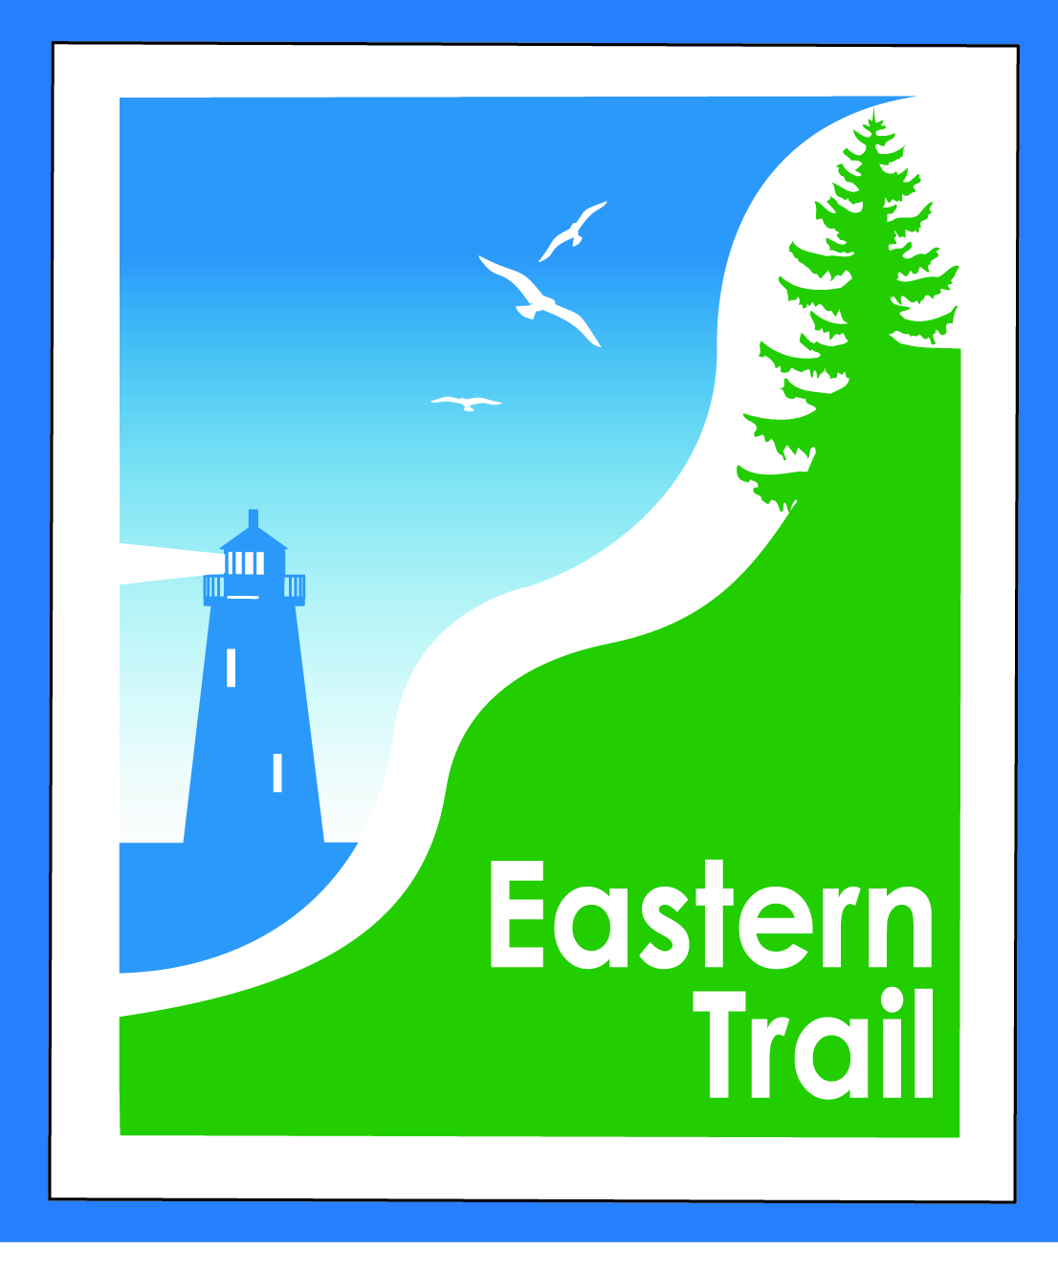

ETMD Board of Directors – Minutes
Kennebunk Town Hall - Third Floor Conference Rm – September 13, 2017 - 8:30 – 10:30 a.m.
  - Attendees:
    - Officers: Eric Labelle, VP; Bill Reichl, Pres.; Val Camire, Treas.
    - Trustees: Marianne Goodine, Joe Yuhas, Jim Bucar,
    - Guests: Keith Trefethen, Arundel Town Manager
    - Staff: Carole Brush, Executive Director
1. Welcome & Introductions: Meeting convened at 8:33 AM Pres. Reichl initiated introductions.
- Update: on Hallczuk Dog situation: Town Manager Keith Trefethen shared with the Board the town’s petition to the Court to have the resident dog removed from Mr. Hallczuk and their request to the court to prohibit Mr. Hallczuk from having any dogs on his premises in the future. Arraignment set for October 4th; court date to be advised after that. ETMD will provide summary of all incidents over the past 7 years to the town prior to court date and continue to provide support to Arundel as this moves forward. (Post meeting update: Court date set for 12/05; 8:30 AM, Biddeford)
- Minutes of August 9, 2017: Motion to approve: Joe Y, second Jim B, vote to approve unanimous

- Financials:
  - Motion to approve August financial repot: Joe Y, second Jim B, vote to approve unanimous
  - Carole B reported all dues anticipated for FY 2018 are committed & will be received by October.
  - Carole B reported that ETA will discuss ETMD’s request for additional funding to cover shortfall of $10 - $15k at their September 20th meeting. She will report back to ETMD at October11th meeting. Bill R will provide statement with ETMD’s request to ETA prior to their meeting that will include the contents of Jim B’s email with suggestions on how this may be handled.
  - Event Policy: Bill R moved to revise going forward as follows: No fee for non profit organizations; change fees for the for profit events from $500 flat fee to $100 plus $10 per participant based on the event’s final numbers. Second Eric L. Motion to approve: Unanimous
- Operations:
  - Cape Arundel connection: Is still not resolved. Carole B to ask Keith T to facilitate meeting between Arundel, Cape Arundel and ETMD to resolve. ETMD requesting two-way access or $ in lieu if not granted. (Post Meeting update: Carole has reached out to Tad and Keith – no response to date. Bring up at October meeting)
  - Position – Eastern Trail proposed development – OOB-Saco: Motion by Bill R: ETMD will grant access to ET as long as there is a public easement in place to Ross Road at a mutually agreed location. Second
  - Joe Y. Motion to approve: Unanimous (Post meeting update: Final approval for plans anticipated at OOB Town Meeting on October 12th – ETMD should have representative there.)

- Ongoing / Proposed Projects:
  - Scarborough – Close the Gap: Carole and Bill both reported there have been no recent updates. Carole to set strategy meeting with the Close the Gap team in early October to discuss. Key items to resolve are the easement request to Hale and raising the final $480k.
  - Kennebunk – Wells: Marianne reported date to file survey report with MaineDOT extended to 9/30. Carole will check in with Kennebunk Town Engineer, Chris O re status and timing of final survey.
  - No news reported from Municipalities

- Outreach & Events: Carole B reported that there are four events by other organizations occurring on the ET during September and October. All are non profit events – two in Kennebunk through the Middle and High Schools; two at Thornton Academy in Saco – Juvenile Diabetes and Chari Foundation. The ETA is also offering monthly full moon walks in Kennebunk, Biddeford and Scarborough. Joe Yuhas will also lead two additional walks in September – one for Grandparents/Grandchildren co sponsored by AARP in Kennebunk and one sunset walk in Scarborough for the Great Maine Outdoor Weekend – both occur at the end of September.

- Other Business: Jim B initiated a second Economic Impact Study on the ET in July. Counters installed on off road sections from Scarborough through Kennebunk. Survey revised and will be put up on web, FB, in kiosks and handed out at events on the trail. Data will be collected through May to provide nine months of data gathering. Initial results show much higher use than reported in 2013-2014. When large groups present the counters do not capture all. This is due to walkers/cyclists riding three and four abreast as well as the built in timing delay to prevent double counting. When completed the EIS will be a huge benefit when seeking funding.

- Next Meeting: October 11, 2017

- Meeting suspended at 9:47 AM (no longer had quorum by end of meeting)

