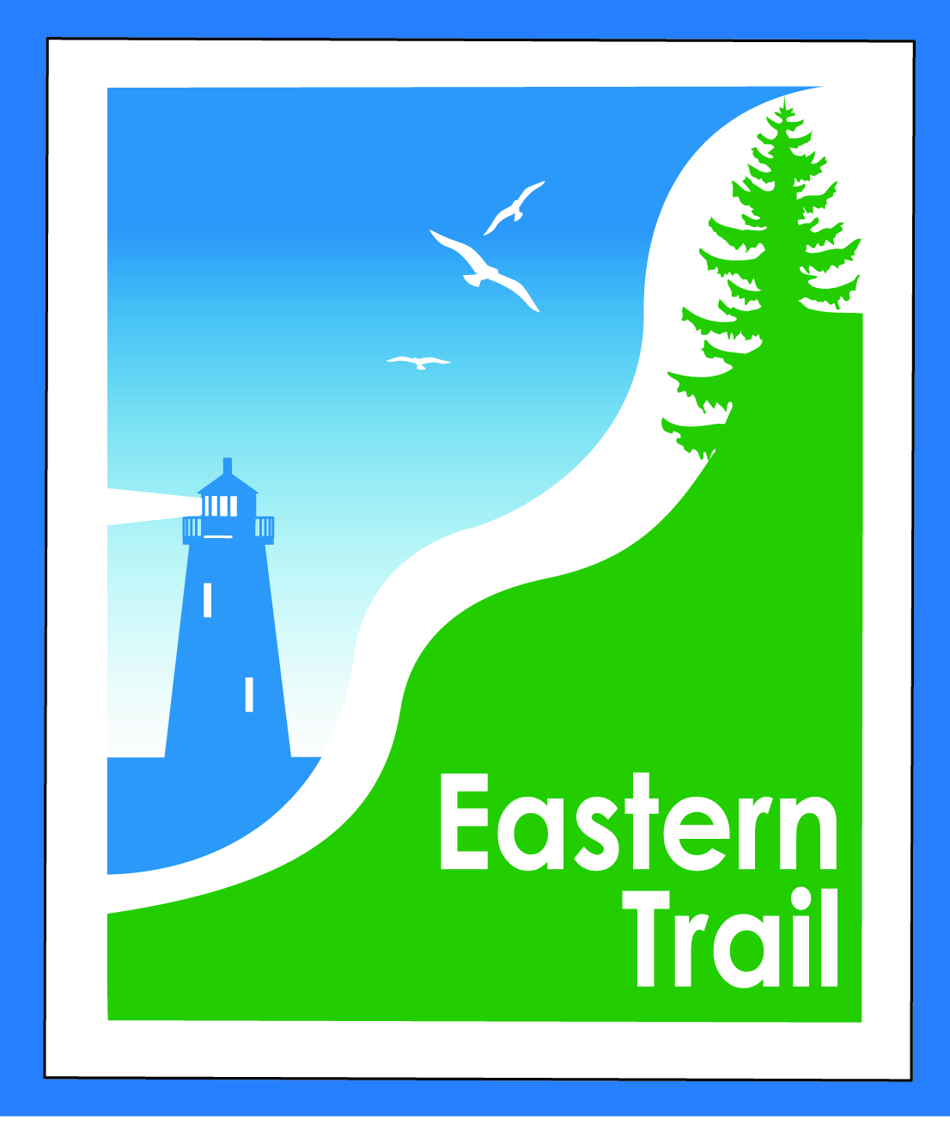

ETMD Board of Directors –Agenda
Kennebunk Town Hall - Third Floor Conference Rm – September 13, 2017 - 8:30 – 10:30 a.m.

- Welcome & Introductions – 2 min
- Minutes of June 14, 2017 (Tad to send) & August 9, 2017 (attached) needs vote - 5 min

- Financial – 5 min
  - August report (attached) - needs vote – Carole, Val
  - Dues status - Carole
  - Details - Financial appeal to ETA – All
  - Revise Event Fee policy – All
- Operations – 45 min
  - Legal position – Hallczuk dog issue - Tad
  - Cape Arundel connection – Tad
  - Position – Eastern Trail proposed development – OOB-Saco

- Ongoing / Proposed Projects: 45 min
  - Scarborough – 019386.00 Bill, Carole
  - Status Kennebunk – Wells – Marianne, Eric, Carole
  - Reports from Municipalities

- Outreach & Events – 15 min – Carole
  - September, October events

- Other Business? – 3 min

- Next Meeting – October 11, 2017

- Adjourn

