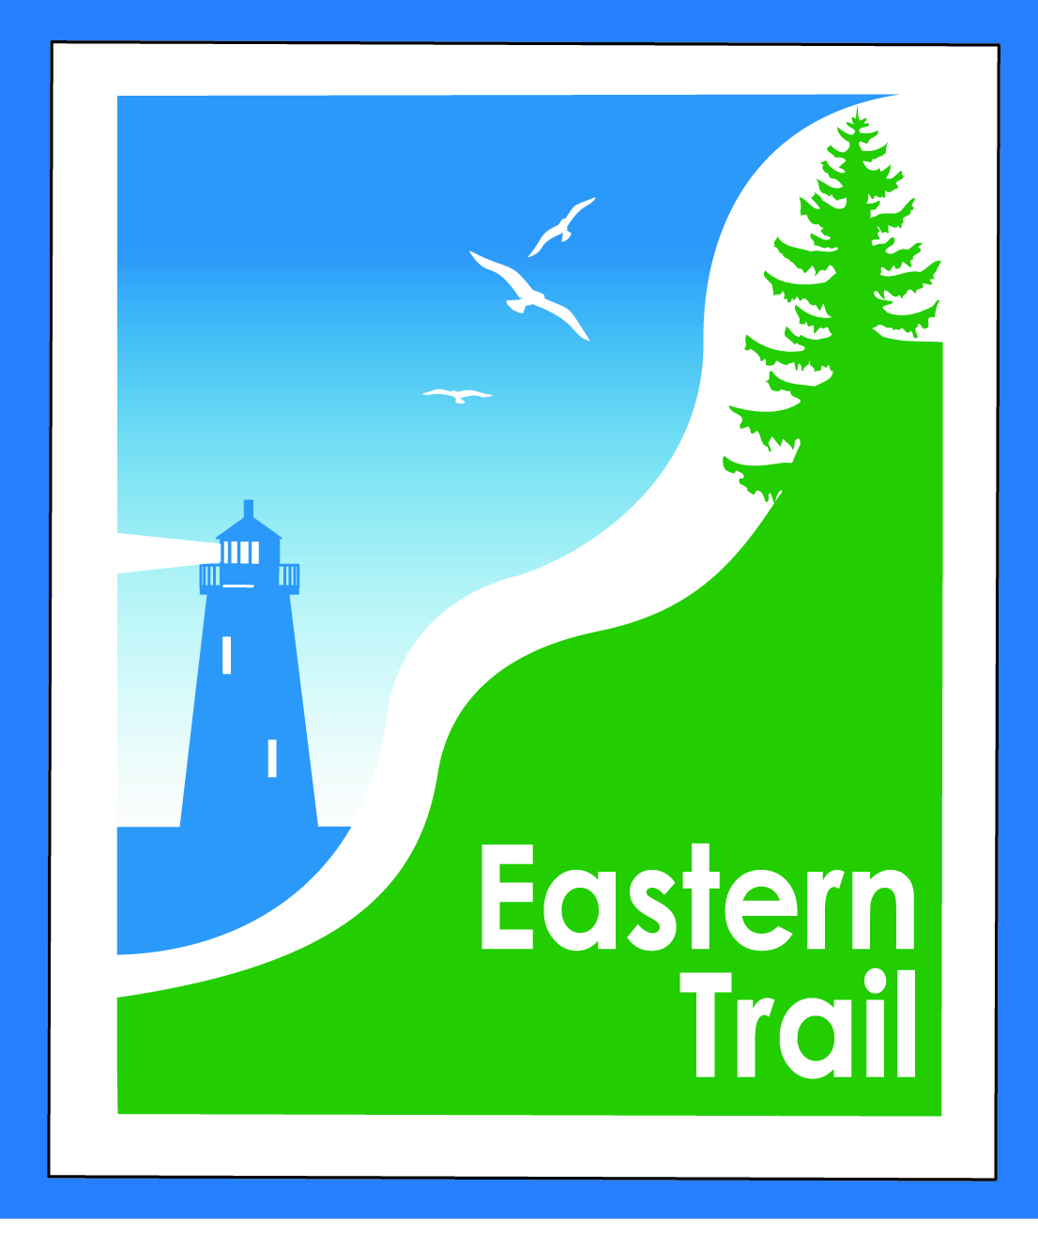

ETMD Board of Directors
Meeting Minutes – Wednesday, September 11, 2019
Present: Officers: Bill Reichl, Scarborough, President; Val Camire, OOB, Treasurer
Trustees: Joe Yuhas, ETA; Tom McCollum, South Berwick; Bryan Laverriere, Operations Dir., DPW, Kennebunk; Ryan Sommer, Parks & Rec Director, Saco
Staff: Carole Brush, Executive Director – ETMD, Nancy Borg, Executive Director - ETA
- Welcome & Introductions – 8:35 a.m.
- Minutes of August 14, 2019 – Motion by Joe, 2nd by Bryan to accept Minutes. All in favor.

- Financial
  - August – Motion by Joe, 2nd by Bryan to accept August Financials. All in favor.
  - Dues status – Carole reported that N.B. will pay dues mid-October. Biddeford Dues paid
Carole will reach out to South Berwick re their $500 commitment.
- Operations – 30 min
  - Maintenance - After discussions with Unitil, our insurance carrier and various municipalities, with the presence of an ETA Ambassador or Board member, volunteers will be given permission to maintain the upkeep of the trails – with limitations. ETA & ETMD will have a liability waiver drawn up for these activities. Once waiver is drawn up, ETMD Board will vote for these activities to proceed. Open Items – what to do with debris from maintenance activities. Once approved, with work in chorus with public works/recreation departments and Eastern Trail for Trail Day clean up events.
  - Reports from Municipalities: Kbunk – Bridge approach requiring attention – Carole reached out to HNTB and asked if they plus MTA will work with Bryan regarding the filler currently there and what may need to be added. No concern of closing the bridge at this time. Saco – paving to wait until spring for cost savings. Scarborough – IFW approved possibility of paving of Pine Point parking lot. Scarborough Marsh Bridge still an issue regarding floorboards causing tripping. Bridge constructed in a manner that a repair is not necessarily easy. OOB – Val reported that bit by bit the debris on the property adjacent to the trail near Millbrook is being removed per request of code enforcement officials.
- Ongoing / Proposed Projects – 60 min
  - Close the Gap – Scarborough – 019386.00 – Disappointing news, yet again. Scarborough attorneys are now reviewing the assessment reports, rite of way easements, land owner property lines, etc., working in the most cost efficient way. Once the reports are completed,(projected to be the week of 9/23) they can then approach land owners regarding easements. May run into landowners requesting high reimbursements. CMP will amend agreement regarding DeFosses portion of the trail to our advantage. Once agreement has been amended, it will require ETA & ETMD Presidents’ signatures.
  - Over the River – Saco-Biddeford connection – No word from Kevin - Ryan will follow up and report back regarding meeting or discussion with Pan Am.
  - Blazing the Trail South – Kennebunk – South Berwick - Kristin Keeney of ECG requesting information regarding the projected route and cost from Kittery thru Eliot to the Berwicks. Some suggestions made for alternate, less attractive routes. Tom M suggested her reviewing Quad maps to understand the various options. $ to complete this section or further town input not feasible at this time. Kennebunk and Wells Surveys are now complete and North Berwick Line to Pratt & Whitney. Time to schedule a meeting with Unitil to discuss colocation agreement and help us understand design alignment within their right of way so we can refine costs. Waiting on Wells to prepare a similar report we received from Chris of KBunk to understand projected costs. Design Costs (need to verify if this includes permitting?) Wells - $625K and KBunk - $266K.
  - Funding – Private funding and ETA outreach = $158K earmarked for design. Possible additional funds from ETA events ($23k) and/or potential for match from ETA for Annual Appeal (Requires Board approval) for design costs. Will see if Wells & Kennebunk could also consider approving a matching challenge grant.
  - Grants –Most grant funding needs reports to show work in progress on projects within one year of receipt of funds, otherwise will have to give funds back. Hesitant to pursue additional grant funding until we have more $$ committed from public & private sources.

- Outreach & Events – 5 min
  - Upcoming ETA / ETMD events ETA finished MLR with 500 participants due to low registration and Hurricane Dorian, 10K being held on Sunday, September 22, and Maine Marathon (ETA beneficiary) Sunday, Oct 6.
  - Carole reported on various organizations and outreach events she is currently attending – Maine Trail Coalition, York County Trails. Scheduled to present to Presentations to Wells Conservation Commission, WTS (Women’s Technical Seminar), OLLI and Volksport Assn. Will reach out to various organizations to invite them to use the trail for their fundraising – Barbara Bush, AARP, etc. Please bring any other suggestions to either Nancy or Carole.

- Other Business – None
- Next Meeting – October 9, 2019
- Adjourn – Motion by Joe, 2nd by Val to adjourn. All in favor.
- Meeting Adjourned – 9:40AM

Minutes prepared & submitted by Nancy Borg, ETA Executive Director

