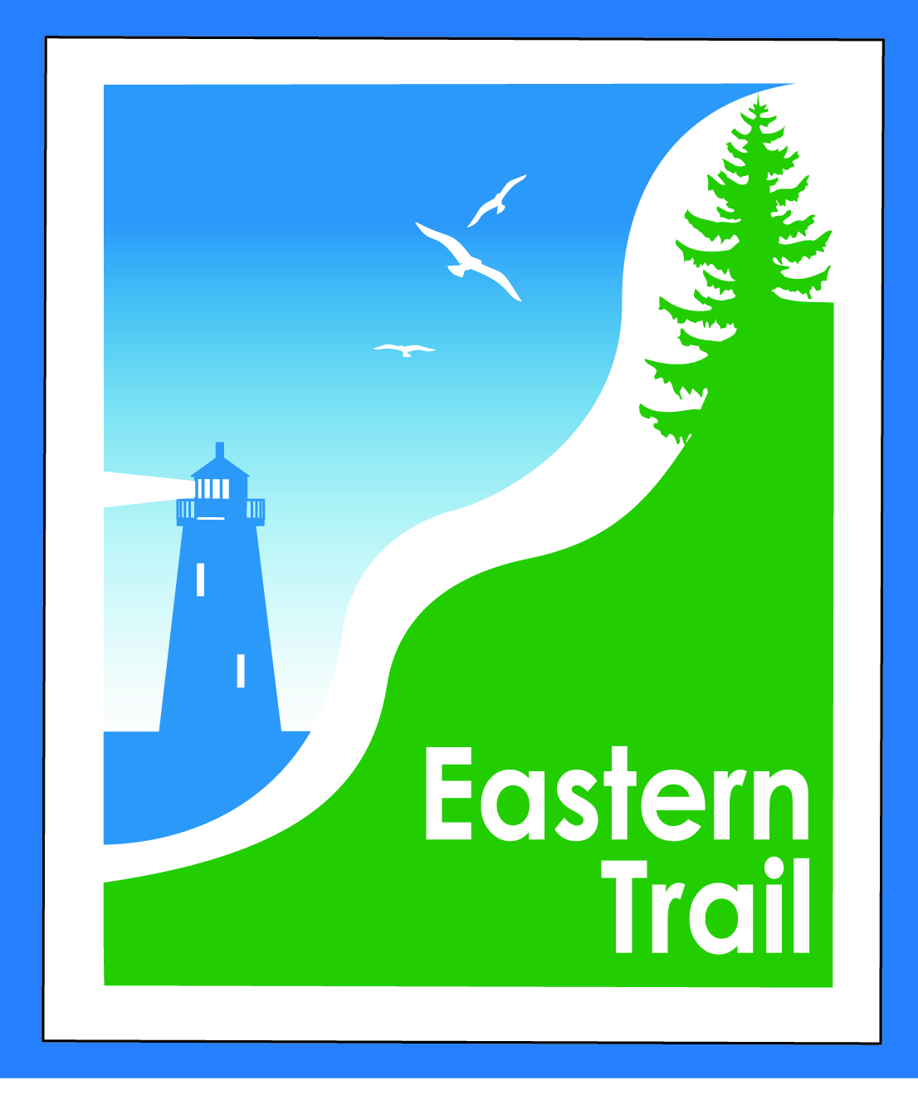
ETMD Board of Directors Agenda
Kennebunk Town Hall - Third Floor Conference Rm – August 14, 2019 - 8:30 – 10:30 a.m.

- Welcome & Introductions – 5 min
- Minutes of June 12, 2019 – attached - needs vote - 5 min (the July meeting was canceled)

- Financial – 15 min
  - June & July reports – attached - needs vote – Carole, Val
  - Dues status – Carole
- Operations – 30 min
  - Maintenance (summary to follow) - all
  - Reports from Municipalities - all
- Ongoing / Proposed Projects - 60 min
  - Close the Gap - Scarborough – 019386.00 – Bill
  - Over the River – Saco-Biddeford connection – Greg, Ryan, Carole
  - Blazing the Trail South - Kennebunk – South Berwick –- Carole, Marianne, Bryan, Tom
  - Eliot, Kittery route – off road options? – Carole
  - Creative Trail Funding – All

- Outreach & Events – 5 min
  - Upcoming ETA / ETMD events – Carole, Nancy

- Other Business? – 5 min
- Next Meeting – September 11, 2019
- Adjourn

