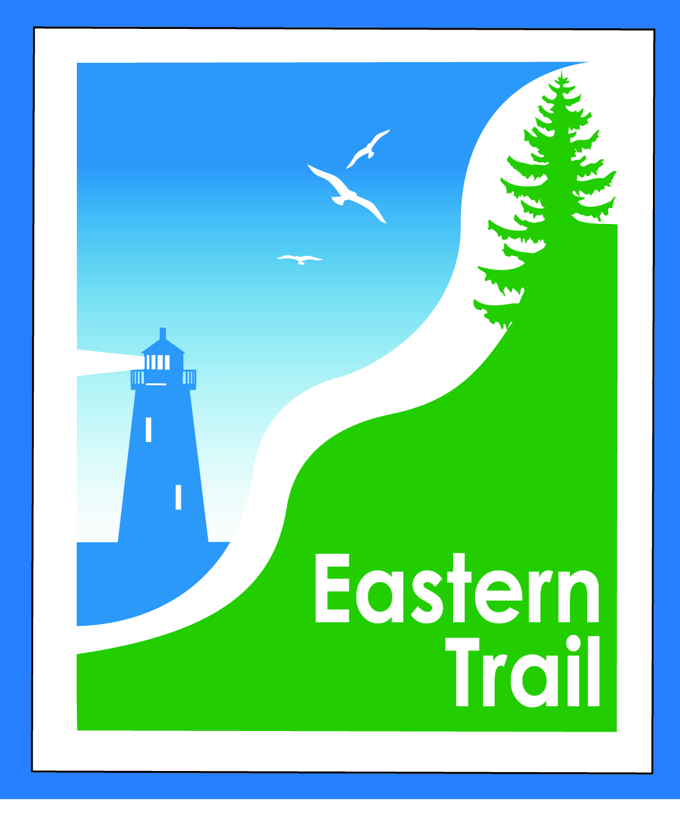

ETMD Board of Directors – REVISED Agenda
Kennebunk Town Hall - Third Floor Conference Rm – August 12, 2015 - 8:30 – 10:30 a.m.
- Introductions – 1 min
- Minutes of June 10, 2015 (sent) – needs vote - 2 min
- Financial Report – Carole (sent) – needs vote – 2 min
  - Primary OOB rep and Treasurer status – Val – 5 min
  - Review of 2016 proposed budget – Val (sent) – needs vote - 10 min
- ETMD Priorities - 75 min
  - Management Policies & Procedures
    - Recent trail issues – (6 recent issues with Halczuk’s dogs) Marianne/Carole/Tad
    - Bench requests/policy – Marianne/Carole/Greg
    - Trail Maintenance/Repairs/Municipal Reports –Bob/Marianne/Carole
      - Signs – directional and “thank you Unitil” – Bob
      - Status (CB deliver report at meeting)
      - MDOT letter (Bob H)
      - Reports from Municipalities
    - Future ET planning – Marianne / Carole
      - Outreach & funding
        - 2016 dues, Unitil Co Lo status, current outreach efforts – Carole
        - Unitil corridor access request – John A – Needs vote
- Current Projects - 15 min
    - Kennebunk - design status – Tom M
    - OOB Spur trail – Jim B, Val
    - Scarborough – 019386.00 - Bill R
      - $150,000 .8 mi. design update
      - Pleasant Hill Rd – SoPo town line update
    - Wells – design status – Marianne …
- Events – 3 min - Carole/Bob H
    - Report on ETMD 2015 events, estimate on 2016 events (covered under Budget above)
    - Update on ETA initiatives – Bob H, Carole B
- Other Business - 2 min – issues? Concerns
- Next Meeting – September 9, 2015 (NO CB at this one)
- Adjourn

