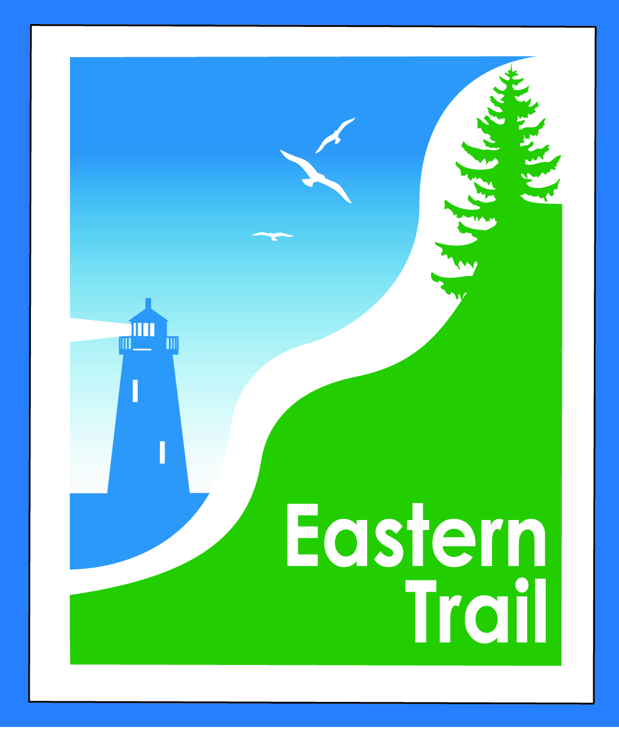

ETMD Board of Directors – Agenda
Kennebunk Town Hall - Third Floor Conference Rm – July 8, 2015 - 8:30 – 10:30 a.m.
- Minutes of June 10, 2015 (Bill R will send) – needs vote - 3 min
- Financial Report – Carole (will follow) – needs vote – 2 min
  - Review of 2016 proposed budget – Val (will follow) – needs vote - 15 min
- ETMD Priorities 90 min
  - Management Policies & Procedures
    - Future ET planning – Marianne / Carole
      - Status 2016 dues
      - Outreach & funding
    - Bench requests/policy – Marianne/Carole
    - Reports from Municipalities
    - Trail Maintenance/Repairs – Marianne/Carole
      - Status
      - MDOT letter
      - Next steps
- Ongoing / Proposed Projects: 10 min
  - Scarborough – 019386.00 Bill R
    - $150,000 .8 mi. design update
    - Pleasant Hill Rd – SoPo town line update
- Outreach & Events – Carole/Bob H
    - Report on ETMD 2015 events, estimate on 2016 events
    - Report on ETA Issues & Direction Workshop – Bob H
- Other Business – issues? Concerns? 5 min
- Next Meeting – August 12, 2015
- Adjourn

