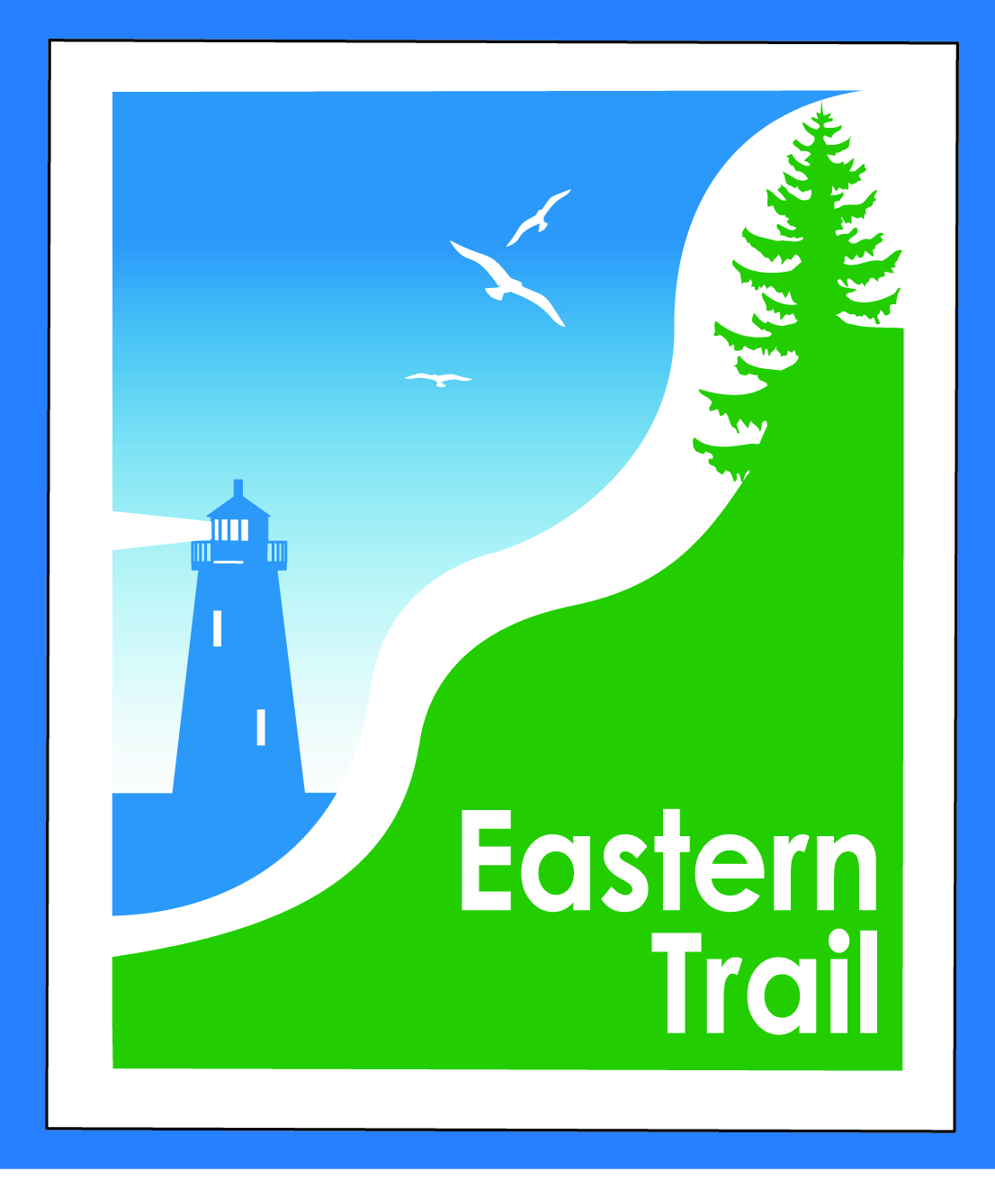

ETMD Board of Directors – Minutes
Kennebunk Town Hall - Third Floor Conference Rm – June 8, 2016 - 8:30 – 10:30 a.m.
In Attendance:
Board:
Marianne Goodine, Chair – Wells
Bill Reichl, Vice-Chair – Scarborough
Greg Tansley – Secretary – Biddeford
Valdine Camire – Treasurer - Old Orchard Beach
Bob Hamblen – Saco
Eric Labelle – Kennebunk (arrived at 9:25 AM)
Tom McCallum – South Berwick
Joe Yuhas – ETA
John Andrews – ETA
Guests:
Carole Brush – ETMD – Executive Director
Meeting called to order at 8:40 AM

- Minutes of May 11, 2016:
- Motion to Approve w typo corrections Andrews/seconded by Yuhas/Unanimous

- ETMD Priorities:
  - Dues Status – 2nd notice sent 6/01, status from municipalities
    - Carole - Dues letters are out. Scarborough has paid early.
  - Location and date for Annual DPW meeting – All
    - Carole - Scarborough cannot do it this year. Any other communities willing? Should we expand to include Parks and Recreation people?
    - General Board discussion about maintenance in Biddeford, Saco, and Scarborough.
    - Yuhas – The area where there was the washout in Biddeford is settling and may need to be addressed. Carole – will talk to Unitil when the sign is being installed.
    - Hamblen – Maybe do the DPW meeting every two years?
    - Reichl – Parks and Recreation folks in Southern Maine get together quarterly. Maybe ETMD could be invited. December meeting?
    - McCallum – Do DPW folks from around the area get together periodically? Greg – Doesn’t think so. McCallum – a meeting amongst them might help the towns without a trail yet. The Board agreed to look into an informal meeting (breakfast, lunch, etc.) between DPW and Parks and Recreation folks in the future.

- Ongoing / Proposed Projects:
  - Scarborough – 019386.00 Bill R, Carole B (grassroots)
    - Reichl – Moving slowly. Survey work was to be completed 1-2 weeks from now. Wildlife people are delineating wildlife areas. The Town approved $216,000 to go towards the project. Encountering some wetland permitting glitches.
    - Brush – Grassroots campaign; brought in $32000 to date, including $10k from Davis Conservation Fund grant. Pursuing additional grant opportunities.
  - Status Kennebunk – Wells – Marianne, Eric
    - No discussion.
  - Reports from Municipalities
    - No discussion.
  - General discussion about “Crowdsourcing”. Hamblen – Has ETA/ETMD ever done crowdsourcing to raise $ Carole – Have thought about it. Yuhas – Ethan Davis is familiar with this. Andrews – Will contact Richard Pelletier.

- ETMD Priorities:
  - Election of Officers - Marianne
    - Hamblen – Nominates Reichl as President. Yuhas – Seconds. Unanimous.
    - Andrews – Nominates LaBelle as Vice-President. Reichl seconds. Unanimous.
    - Andrews – Nominates McCallum as Secretary. McCallum – Would prefer not to until he is more familiar with the organization.
    - Hamblen – Nominates Redway as Secretary. Reichl seconds. Unanimous. Note: Hamblen agreed to step in if Redway can’t make a meeting.
    - Hamblen – Nominates Camire as Treasurer. Goodine seconds. Unanimous.
    - Carole – Noted she will have to go back to the bank with the Officers.

- Financial Report – Carole
    - Yuhas motions to accept the May Treasurers Report. Hamblen seconds. Unanimous.
    - Carole – Noted that hours and travel are up due to increase in outreach and on projects. Noted that she estimates we will be $2,130.57 over budget at the end of the year. Noted that in addition to in house costs, hours and travel, outlay for Close the Gap promotional materials is high – will mention to CTG committee to see if there’s cost sharing available.
    - Carole – Dues history has been pretty consistent over the past few years.
  - Review of 2017 proposed budget – Val
    - Carole – Camire and Carole worked on the budget.
    - Tansley suggested approaching SMHC, Martin’s Point, and Sweetser as possible funding supporters. Hamblen and Tansley to get Carole contact information.
    - Carole – Should we try selling more benches? Reichl and LaBelle raised a concern that they actually cost the communities over time. Reichl said that Scarborough has an agreement with people about the maintenance of benches. Reichl to get a copy to Carole.
    - #1. Hamblen motions to approve the 2017 budget. Andrews seconds.
    - #2. Andrews motions to cover the deficit from reserves. Hamblen seconds.
    - #3. LaBelle motions to look for additional revenues. Reichl seconds.
    - No further motions.
    - Vote on #3: Unanimous.
    - Vote on #2: Unanimous.
    - Vote on #1 (original motion): Unanimous.
    - Marianne brought up there’s been no increase in ED’s compensation for over 7 years, Reichl will discuss with Board off line and bring back recommendations in July
    - Carole – initiated a discussion on the sponsorship of a ¼ mile of trail.
      - One time up front cost of $2,500 to Grass roots fundraising to “Close the Gap”.
      - Continued sponsorship on a yearly basis with $ to ETMD.
      - $ to be worked out with final action by ETMD in July.
- Outreach & Events – Carole/Bob H
- Report on ECGA May 25th meeting, request for comments/attendance for June 7th meeting
  - Hamblen mentions ECG could supply more support for ET through lobbying in Congress on the national and state levels.
- Report on ETMD 2016 booked events, ETA Annual Meeting
    - Need to reach out for more events, current groups pushing back on $ charge
    - ETA Annual Meeting largest ever (90+), focus Close the Gap brought in $2500
- Funding Sources and strategies – Carole
  - (Discussed earlier)
- Other Business – issues? Concerns?
  - No discussion.
- Next Meeting – July 13, 2016
- Adjourn
  - Andrews motions to adjourn. Yuhas seconds. Unanimous. Meeting adjourned at 10:35.

