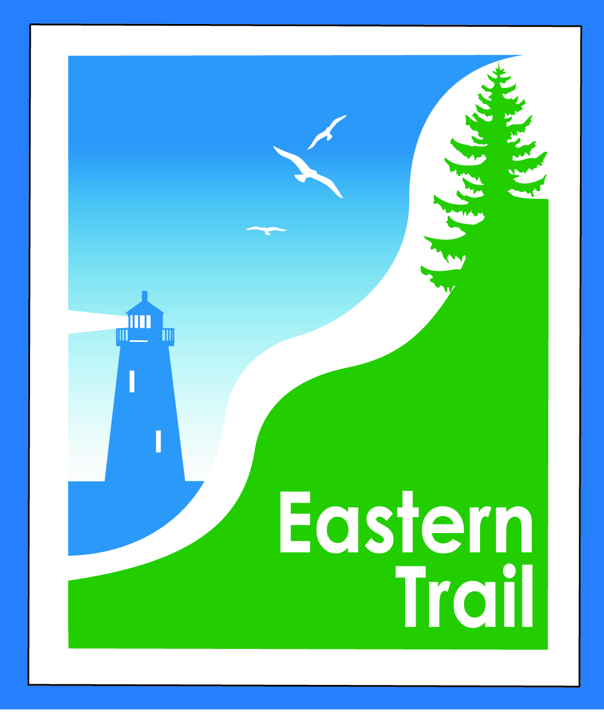

ETMD Board of Directors – Agenda
Kennebunk Town Hall - Third Floor Conference Rm – June 8, 2016 - 8:30 – 10:30 a.m.
- Minutes of May 11, 2016 (included)– needs vote - 2 min
- Financial Report – Carole (will follow) – needs vote – 3 min
  - Review of 2017 proposed budget – Val (will follow) – needs vote - 15 min
- ETMD Priorities 75 min
  - Election of Officers - Marianne
  - Dues Status – 2nd notice sent 6/01, status from municipalities
  - Location and date for Annual DPW meeting – All
- Ongoing / Proposed Projects: 23 min
  - Scarborough – 019386.00 Bill R, Carole B (grassroots)
  - Status Kennebunk – Wells – Marianne, Eric
  - Reports from Municipalities
- Outreach & Events – Carole/Bob H
    - Report on ECGA May 25th & June 7th meetings, request for comments from attendees
    - Report on ETMD 2016 booked events, ETA Annual Meeting
    - Funding Sources and strategies – Carole
- Other Business – issues? Concerns? 2 min
- Next Meeting – July 13, 2016
- Adjourn

