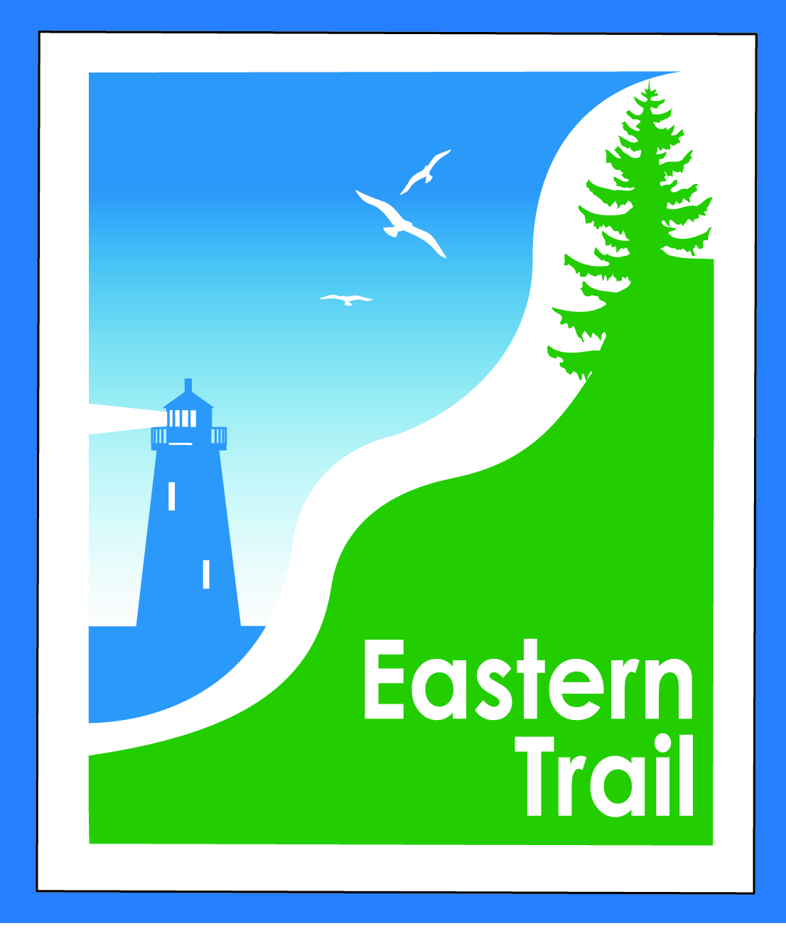

ETMD Board of Directors – Agenda
Kennebunk Town Hall - Third Floor Conference Rm – May 11, 2016 - 8:30 – 10:30 a.m.

- Introductions – 3 min

- Minutes of April 13 2016 – included– needs vote - 2 min

- Financial Priorities – 20 min
- Review of current financial report – Val/Carole – to follow – needs vote
  - Budget status, year end projection, 2017 considerations – Val/Carole
- Dues, Annual ETMD Report & Events – 2016 status – see ED reports to follow

- ETMD Priorities - 90 min
  - Schedule Annual DPW Meeting, include Parks & Rec – All
  - Current Project Status:
    - Scarborough – Bill R
    - Kennebunk – Wells - Marianne G
    - South Berwick – Vine St Bridge – Tom McCullum
  - Update on Farm Gate proposal from Unitil – Carole B
    - Discussion/decisions - all
  - Reports from Executive Director and Municipalities (existing trail conditions, maintenance concerns)
  - Future ET planning – Carole – 3 min
    - ECGA Meetings – May 25th & June 7th
    - ETA Annual Meeting & Close the Gap campaign – May 25th Clambake, Scarborough
    - Grant submittal and outreach status – see ED report to follow

- Other Business - 2 min – issues? Concerns

- Next Meeting – June 8, 2016

- Adjourn

