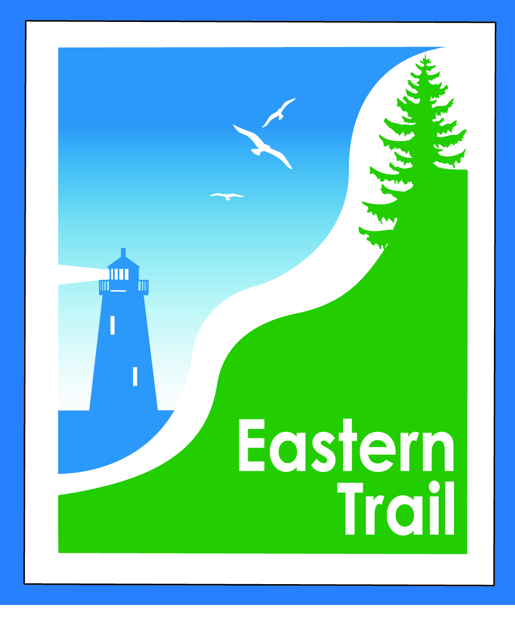
ETMD Board of Directors Agenda
April 08, 2020 - 8:30 – 10:30 a.m.

Zoom meeting. Topic: ETMD Board Meeting
Time: Apr 8, 2020 08:30 AM Eastern Time (US and Canada)
Join Zoom Meeting https://zoom.us/j/5536351213
Meeting ID: 553 635 1213
8:30 AM Welcome & Introductions

8:35 AM Consent Agenda – VOTE on: Bill, Carole
- March meeting minutes (attached)
- March Treasurer’s Report (attached)
- Review and approval of RHR Draft Audit 3-31-2020 (sent last week)
- Check signing process under CV-19

8:55 AM Operations Greg, Bob, Bill, Carole
- Status on ED Succession Planning
  - Updates from Committee Meeting Greg, Bob
    - Timeline, job description, compensation, hiring committee
- Updates on active projects
  - Close The Gap – South Portland to Scarborough Bill
  - Over The River - Saco to Biddeford Carole
  - Blazing The Trail South – Kennebunk to South Berwick Carole
- ED monthly report Carole
  - Ironman event
  - Dues status
  - Trail Maintenance
- Status reports from municipalities, ETA All
  - Operating impacts of COVID-19

10:15 New Business?

10:30 Adjourn

Next meeting: May 13, 2020

