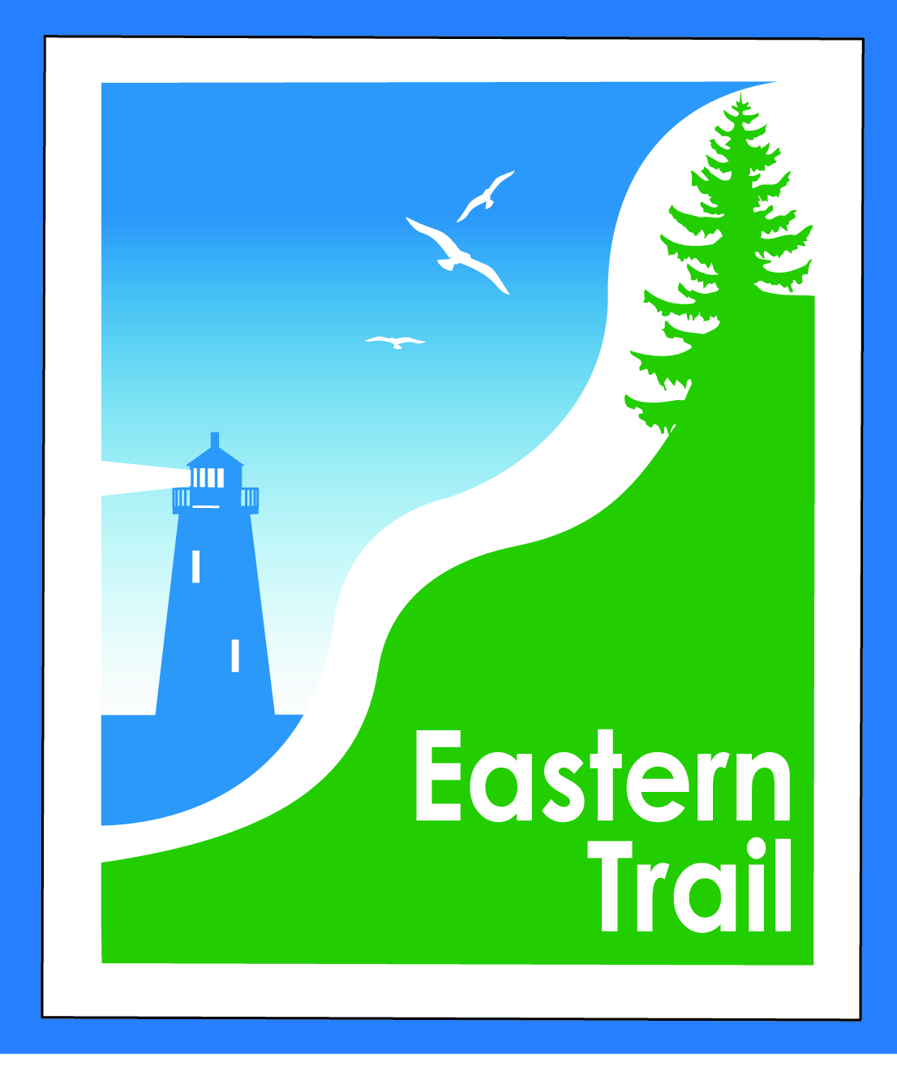
ETMD Board of Directors Agenda
Kennebunk Town Hall - 1 Summer St., 3rd floor Conf Rm – March 11, 2020 - 8:30 – 10:30 a.m.

8:30 AM Welcome & Introductions

8:35 AM Consent Agenda – VOTE on: Bill, Carole
- February meeting minutes
- February Treasurer’s Report
- Change of Registered Agent

8:55 AM Operations Bill, Tad, Carole, Greg
- Discussion and votes on:
  - Succession Planning for ETMD & ETA ED Tad
    - review ETMD budget for ED position
    - one position or two?
    - review responsibilities for each position and discuss overlap
  - Next steps for active projects (see detail in ED report):
    - Close The Gap – South Portland to Scarborough
      - Status report Bill
      - Meeting of stakeholders
    - Over The River - Saco to Biddeford
      - Submit Planning Partnership Initiative request
    - Blazing The Trail South – Kennebunk to South Berwick
      - Submit 2 Planning Partnership Initiative requests
- Reports from municipalities, ETA
- ?’s on ED Report

10:25 New Business?

10:30 Adjourn

Next meeting: April 8, 2020

