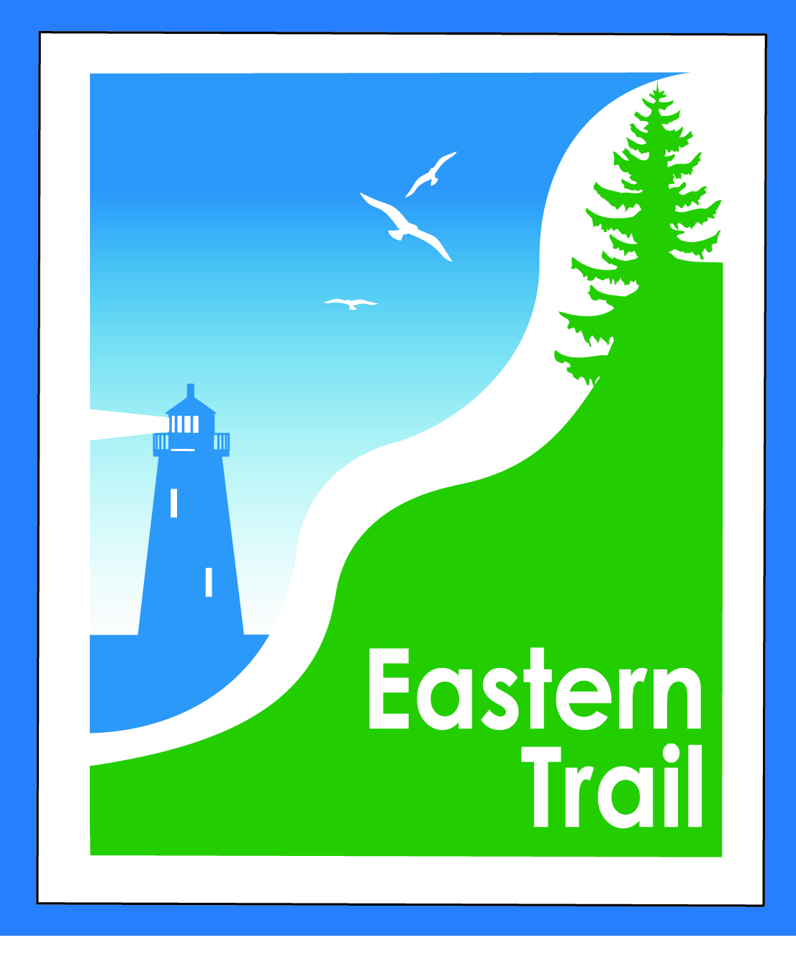

ETMD Board of Directors Minutes
September 12, 2018

Present: Officers Bill Reichl, Scarborough, President; Marianne Goodine, Wells, Secretary
Trustees: Greg Tansley, Biddeford; Ryan Sommer, Parks and Rec Director, Saco; Bryan Laverriere, Operations Mgr., DPW, Kennebunk; Joe Yuhas, ETA, Jim Bucar, ETA, Bob Hamblen, ETA; Tom McCullum, South Berwick
Guest: Jason Webber, Rec Director, OOB
Staff: Carole Brush, Executive Director – ETA/ETMD
- Welcome & Introductions – 8:30a.m.
- Review of IronMan – 2018 & 2019 – with Jason Webber, Rec Director, OOB and Conference Call with Audra Tassone, Eric Opdyke and A.J. Sills, reps from Ironman. Group had lengthy discussion on what reasonable fees should be assessed to IronMan for use of trail for their race. ETMD original request was for $10 per registrant. OOB and IronMan did not like that amount and thought it was too high. ETMD is looking for ways to off-set our costs due to changes in our structure and operations. A $2 pp registrant fee was then discussed – which for IronMan would equal $5000 for their 2500 registered athletes. OOB & other ETMD municipalities are comfortable with $2 pp. IronMan suggested reduced fees for the coming year and/or limiting fees to the actual # of athletes participating on day of event. ETMD Board believes we should go for the full amount of $5,000. Bryan suggested placing a box on the registration form for a donation to Eastern Trail. IronMan charges $230 - $300 per registrant and has 4-5 different tiers. Consensus with Board is that $2 pp is not too much to charge. Ryan stated that IronMan profits approximately $600,000 from registrations and $5,000 is a very small amount from that. Jim stated effect of increase would only be 1-1/2 % to IronMan’s profit.
After conference call ended, Board members then discussed with Jason Webber separately on what ETMD’s expectations are for “reasonable fees”. Bob stated that it is considered a “user fee” and in this situation it is a reasonable fee. ETMD & OOB will consider closing off the section of trail used by IronMan to outside users on day of event. Jason suggested he will go back and talk to representatives with IronMan and negotiate locking in $5,000 fee for next year plus the additional 3 yr contract IronMan is in process of negotiating with OOB (2019-2022) with caveat that if number of registrants increases, they will re-examine fees paid to ETMD. The Board was in favor of this.
- Minutes of July 13, 2018: Motion to accept by Joe, 2nd by Jim, all in favor.

- Financials: Carole reported no major changes. Still waiting on dues from So. Berwick and Arundel. Motion to accept by Marianne, 2nd by Joe, all in favor.
- Operations: Tabled to next meeting.
- Ongoing / Proposed Projects:
  - Close the Gap - Scarborough – 019386.00 – Bill reported compost blanket application with DEP was approved for catching water off trail – will save $250,000 in expenses, but still cost $55,000 additional fees not accounted for. This was submitted back at the beginning of August which has caused further delay in completing permitting and final design progress.
  - Carole reported that she met with Saco on “Over the River” and Eastern Trail Estates. Trying for $5,000 for use of name, and $5,000 connection fee for ETE. Suggestion from Saco is that Biddeford nail down alternate route and when that’s in hand suggest meeting between Saco & Biddeford management to develop strategy for reaching out to PanAm.
  - Over the River - Suggestion from Saco is that Biddeford nail down alternate route and when that’s in hand suggest meeting between Saco & Biddeford management to develop strategy for reaching out to PanAm. Greg will work on alternate on road plus the proposed off road and reach back out to Carole
  - Blazing the Trail South – Carole has scheduled a phone call with Town Manager in Wells on 9/13/18 to discuss strategy for next round of grant applications. Only funds in that account currently are the $68,000 that was used to complete the survey for 7 of the 11 miles in Kennebunk and Wells and a $5000 grant from Narragansett Number One Foundation towards the next piece of survey work in Wells.
  - Carole has a meeting scheduled with Town of North Berwick, Pratt & Whitney, Hussey Seating & Pike Industries for Nov. 7th. Tad and Greg will accompany her. Time to be determined.
  - South Berwick has not responded to emails or phone calls requesting similar meeting. Tom agreed to check on this.
- Outreach & Events:
  - EIS – Jim is still working on gathering numbers and the last four pages of the study booklet.

- Other Business: None

- Next Meeting – October 10, 2018

- Adjourn – 9:30 a.m.: Motion by Ryan, 2nd by Marianne, voted unanimous to adjourn.

