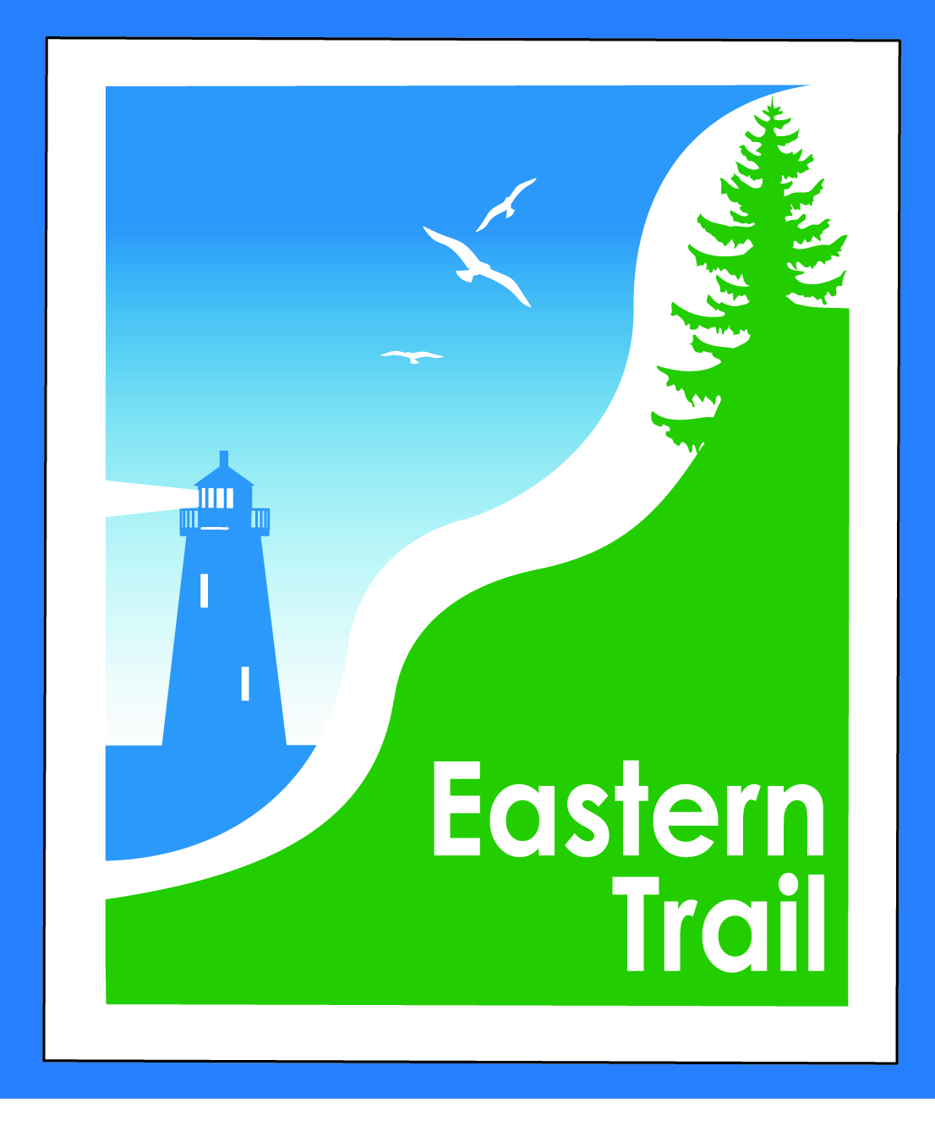

ETMD Board of Directors Minutes
August 9, 2017 - 8:30 – 10:30 a.m.
In attendance:
ETMD Board:
Bill Reichl, Pres. Scarborough
Tom McCullum South Berwick
Eric Labelle, Vice Pres Kennebunk
Greg Tansley Biddeford
Val Camire, Treas OOB
Marianne Goodine Wells
Bob Hamblen, Secy Saco
Jim Bucar ETA
Joe Yuhas ETA
ETA: Pres. Deb Erickson-Irons, Treas. Ralph Hiltz, Vice Pres. Bob Bowker, Trustee Rob Liscomb
STAFF: Carole Brush, ED

- Welcome & Introductions – 2 min – Pres. Reichl initiated introductions.

- ETA – ETMD Budget Review – 45 min – Bill: $10,000 - $15,000 shortfall on projected FY18 budget. Nine dues paying members if South Berwick still in. Last year, same issue, but paid with carry forward account, which we try to avoid so as to have available for repairs, maintenance, etc. Deb: annual ETA-ETMD meeting a good idea. Bob B.: ETMD’s only source of income is the towns, seems somewhat in question. ETA willing to help out, but if this is an annual situation…we have income from memberships and from Maine Lighthouse Ride, but ETA’s costs have risen. Our budget is closer to balanced than to having an annual surplus. How confident is the ETMD that it will be able to balance its budget? Rob: what structurally needs to change at ETMD in order to balance? Is there a role for the ETA? View this as a grant proposal from the ETMD? Is there some way to get the ETMD more stable as it moves forward? Deb: joint planning so that the ETA can anticipate an expense like this would help. Is there a more formal approach that should be considered; more ways to ensure an outreach to member towns? Carole: towns that have dropped out don’t have a trail. We’re getting closer with Kennebunk and Wells, but we always hear, “when?” Fundraising events are a possibility. Deb: can municipal employees participate? Carole: will require support and hours, and can’t be in September. Joe: ETMD ideally is self supporting. With Kennebunk and Wells moving closer to trail building, southward progress will become more apparent. Can we sell involvement of town rec departments? Some new blood could help make this happen. Rob: if money can be given in a visible way, for specific projects, that would help the ETA. Photo-ops make a real difference for us. Bob: we helped OOB out with paving of trail. Ralph: as retired accountant, I haven’t said let’s not cover the shortfall. We need to get South Portland on board. Bill: we’ve spoken to them, and they’ve built their trail, and feel that that’s their contribution. Ralph: does that mean your (SoPo) residents aren’t using the rest of the Trail? Bob: I understand their reluctance, but think they should be on board. The Scarborough section is built, and the towns it goes thru should be contributing. Deb: should come up with a SoPo strategy. Rob: I would say not only with SoPo, but members who live in other towns, too. Ralph: if So. Berwick continues to donate, they deserve our applause. I’m always concerned with spending down ETA resources – can’t just spend; there will be other projects. Deb: can jointly look at our budgets. Hours shift back and forth according to need. Is an expense shift in order? Would need to consider differential in pay rate. Carole would be taking a hit in per personal income if hours increased at ETA to take on ETMD tasks. How many hours does the $15,000 represent? Bob: only way to lower the ETMD budget is, unfortunately, the salary line. Carole: we passed it with a $10,000 shortfall, to take another look in November. Jim: ETMD is paying $40/hour, and ETA $25. How much of deficit for ETMD would an adjustment result in? ETMD is paying a lot more for her services. Carole: previous ED’s were paid at a higher hourly rate than I’m at now. Deb: as employees, or consultants? Consultants. Deb: how can we make sure this doesn’t happen again? Carole: each can help recruit paying events on the Trail. A per participant fee? Rob: would be helpful for the ETMD to come up with a proposal. How would you use the $15,000 to shore up the situation for next year? How can we use publicity about this assist to further ETA’s mission? A 1 or 2 pager as to how this will look moving forward would help. Ralph: I like the idea of a fundraiser, publicize in the area. Rob: if we put a park bench in South Berwick, show evidence of progress, that sort of thing is publicity and gets the town more interested. Basically mini-grants. That will go further to get towns interested. Ralph: we had three free-walkers contact us a few weeks ago, picked them up and dropped them off. I was surprised to see all the ET signs in the back roads of Kennebunk. Bob H.: we don’t capitalize on photo-ops like we should. Bob B.: can we go over the list of towns. Eliot, Kittery, South Berwick, North Berwick all at $3,500, but not proposing to pay this year. Tom: time for me to show my face at town hall again. My fear is Kennebunk and Wells progress, but then the block of North Berwick. No defined off-road route in Kittery or Eliot. I see South Berwick as lagging. Carole: heard from Pratt and Whitney – they’d like to meet, will do so in September. Tom: we have a ride in town, 2-3 from P-W are part of the group. Carole: Rob’s idea of what to put together to came to next ETA meeting is a good one. Bill: if ETMD pays with carry-forward account, figure out our budget going forward, we’ll have to determine when and how we’ll have to cut, recognizing that the time budget line is only place to cut. Deb: are we going to hire a contractor for a project in a town, where town could perhaps get a better price. Rob: we don’t have a Portland Trails-like structure that works well for volunteers. Eric: could do bike trials, or wayfinding. We’re talking about a bike master plan, but town has to budget for that. Just painting and stenciling could happen. Jim: could we do full moon walks elsewhere? Pratt and Whitney? Carole: yes, just need volunteers to do them. Locations for September and October could happen. Had AARP group this past Monday, 97 attendees, on Scarborough Marsh. And a donation jar. Rob: could have a handout for people: your town budget meeting is tomorrow night, if you like this, please support us. Carole: can put more visibility on unbuilt sections, just need more volunteers to help do it. Deb: if we have a calendar of budget meetings, we can plan walks and raise support. Bob: let’s try South Portland again. Bob H.: we need support from ETA members in SoPo. Rob: Mayor is new, we can try. Ralph: I wouldn’t spend a lot of resources trying to get more out of SoPo, but we do need to keep contributing towns. Bill: would ETMD towns support a $1,200 increase? Eric: what’s the value to the added dues? Carole: tourism, real estate values. Jim: should have a new economic impact study next spring. John’s survey in 2014 project to 88,000 users a year, I’m projecting about 150,000. Deb: new ideas fleshed out by next ETA meeting? If we’ve already budgeted ahead of time, and have a list of projects, we don’t need a meeting to vote – Carole can address. Carole: next ETMD meeting is the 13th of September, ETA is 20th. When is meeting with Pratt Whitney? End of September, beginning of October. Bob H.: what will message be to Pratt Whitney? Carole: might like an officer from each organization to attend, too. Might be first of a couple of meetings. Deb: Town and Country message was making connections. It’s not really about this section or that section – it’s all connected, and more usable and more valuable. That’s a message for P-W. Jim: and for SoPo. Not sure we had a good argument until recently. Deb: thanks for having us, and we’ll continue the dialogue.

- Minutes of June 14, 2017 (to follow) & July 12, 2017 (attached) needs vote - 5 min – Bill: any changes? Joe: more to approve, 2nd Jim, and so voted, 9-0.

- Financial – Carole, Val – 5 min
  - July report – Carole: have received OOB’s annual dues, will do some scouting re: South Berwick and follow up with Arundel and Biddeford re timing when checks expected. My expenses not in there. Jim moves to accept, Joe seconded, and so voted, unanimous.

- Operations – 15 min - Carole
  - Cape Arundel request for connection – needs vote – Carole: revised agenda includes this item. We never voted on that. Tad suggests coming up with a $ amount. They gave the ETA $1,000, but that has nothing to do with connecting to the Trail. Is only for their residents. Tom: they don’t want any outsiders coming thru their property? Right. Greg: what would stop them from getting on the Trail? Nothing. Jim: OOB had to submit drawings to Unitil for a trail connection. Eric: if they’re agreeable to opening their property to others, would be a plus. Carole: Kennebunkport Conservation Trust approached them about a connection over their property, but they said no. Greg: suspect if we give a connection to Cape Arundel we’ll never get anything back from them. Jim: we can give an okay as long as homeowners use it responsibly; keep dogs on leashes. Marianne: maybe maintain their spur trail. Tom: they can get to Trail without permission? Yes, but can’t make an 8 foot wide connection. Tom: don’t like the idea that users can’t go the other way. Carole: Silver Springs has a connection, and users not being allowed into campground hasn’t really been an issue. Bill: I say we grant a connection, and ask that Tad work with them for a donation. That’s a motion. Bob H.: 2nd. All in favor. Amendment from Eric: in lieu of providing a fee, they provide a public easement to the Trail. Joe: 2nds. All in favor.

- Ongoing / Proposed Projects: 30 min
  - Scarborough – 019386.00 Bill, Carole – nothing has changed. Hale reached out to Jim Gailey, Grondin to start on road for him, could trail be built at same time? Doesn’t typically happen, but can happen. Carole: now less than $500,000 to raise, but stalled. SEDCO is putting in $7,500 with PACTS for marketing materials, a Scarborough angle, will go out to bid. We need a new look, it is moving slow. Stopped meeting during summer, will pick up in fall.
  - Status Kennebunk – Wells – Marianne, Eric, Carole – Marianne: waiting on Sebago Technics on vernal pool info. Asked Mike Livingston, he’ll follow up with Chris. Eric will follow up with Chris. That report will go to state, SMPDC willing to write next round of grant applications under MPI program.
  - Reports from Municipalities
    - Arundel - Hallczuk dog incident: serious dog incident, Billy’s dog, an 85 year old on a bike, needed skin grafts. Dog is quarantined to Billy’s residence. Spoke to daughter of victim, he’s okay, will not use Trail again. Arundel town manager and attorney are involved. Have talked about banning Billy from Trail, have informed him of that. Attorney is checking on keeping Billy from having a dog again. Nothing in past few weeks. Joe: Arundel resident? Carole: he moved here to be close to Trail, not sure if he’s in Arundel. Jim: there’s a history, but response seems to be just, ‘don’t do that again.’
    - Carole: I get some questions about Scarborough, mowing only after nesting and brooding season. Bill: from Old Blue Point to Eastern Road, IFW owns. Everything is mowed except for Marsh now – won’t be mowed until later in year. Checking into potential of closing gates during hunting season. Brad Zitske, biologist with IFW, checking. Carole: also, a lot of construction at Black Point end. Part of that is a walking trail for the ET. So, some disruption now. Carole: will post on website if needed.

- Outreach & Events – 15 min – Carole
  - EIS update – Jim gave.
  - Ironman – August 27th – they are coming up with signage, for Hannaford in Saco north to Black Point Road. OOB will close its section, Scarborough will not, from 6:30 a.m. to noon. Runners will be on trail from 7:30 AM til 3 or so. Bill: our PD will ask for a ped bridge in future so roads do not have to be closed. OOB had considered, but said no. Reader boards with electronic messages will be used. 800 last year, 2,300 this year. Old Blue Point rest stop is staffed by ETA, does not usually see the full number of runners, but this year we will. ETA still needs volunteers for staffing a rest stop.
  - August, September CTG & ETA events -- Carole: millfield festival in North Berwick, will have a table there. ECG has asked us to sponsor event on Aug. 30, 7 a.m. bird walk in Scarborough, to promote the ECG River Greenway, starting in Calais, looking for promo events along the way. The MLR is now sold out as of today, 1,200 riders. Need volunteers. Scarborough Chamber and Rotary asked about how many $$ will go to Close the Gap? $50,000 has gone to it already, but all proceeds go to the Trail. Some rest stops need staffing. Day of the event, packet handout. Parking attendants, need 5 or 6. Traffic control, keeping riders out of street. Jen@easterntrail.org is volunteer coordinator. Sag drivers, both north and south. Food servers in the afternoon. Friday afternoon, unloading. Beer, water fountain, pizza oven all happen. Saturday a.m., 6-9, traffic, then 11 a.m. on for food service.
  - Upcoming ETMD events – see tab on attached financial report: Carole: Sweetser Sept. 10. 16th, Children’s Tumor Foundation. Also the Chiari event, both on the Trail that day. Sept 17, Juvenile Diabetes, with 500 participants. Oct. 29, on Biddeford section, Ben’s Flight. All non-profits. Do we want to change our policy for for-profits? Discuss at next meeting.

- Other Business? – 3 min

- Next Meeting – September 13, 2017

- Motion to adjourn made by Jim, seconded by Marianne, all in favor.

