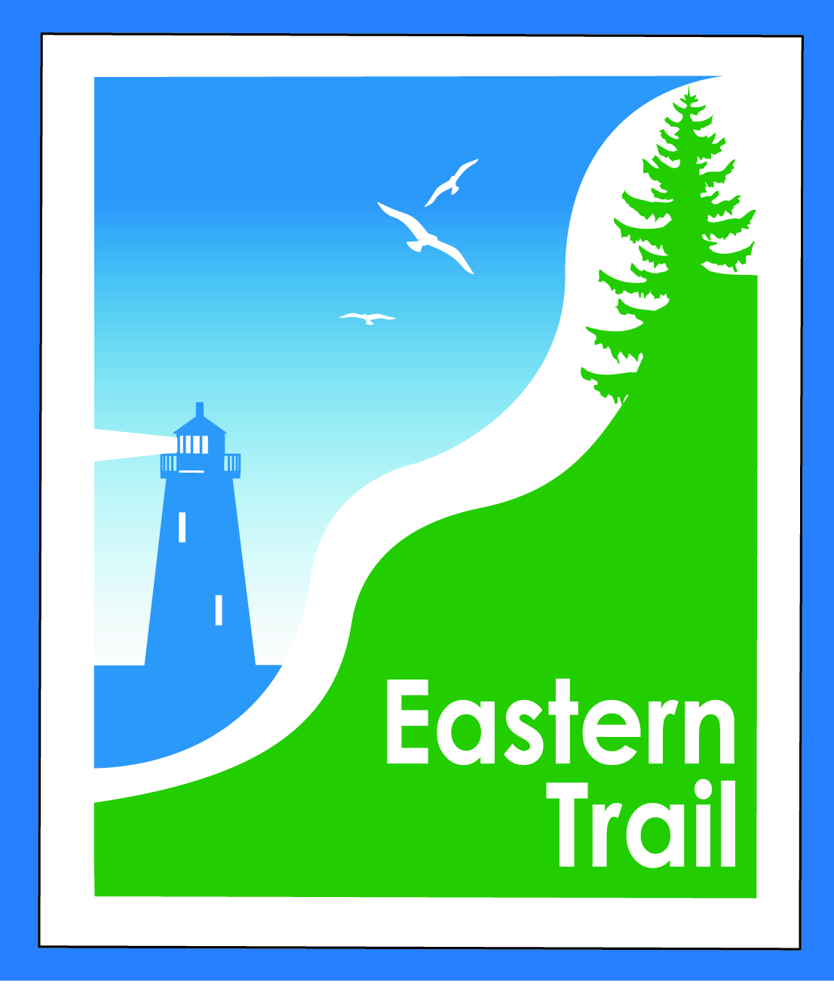

ETMD Board of Directors Agenda
Kennebunk Town Hall - Third Floor Conference Rm – June 13, 2018 - 8:30 – 10:30 a.m.

- Welcome & Introductions – 5 min
- Minutes of May 9, 2018 (sent 6/6) needs vote - 3 min

- Financial – 5 min
  - May report (sent 6/6)- needs vote – Carole, Val
  - Budget for FY 2019 – draft to follow - discussion – All
- Operations – 25 min
  - Election of Officers - Bill
  - Dues status – Carole (invoice & reminders sent 6/03)
  - Hallczuk – Tad, Carole
  - E-bikes – discussion – All
  - Trademark – discussion – All
  - Connection Updates – Tad, Carole
  - Arundel-Kennebunkport Cottage Preserve
  - Arundel Conservation Trust
- Ongoing / Proposed Projects - 25 min
  - Close the Gap - Scarborough – 019386.00 – Bill, Carole
  - Blazing the Trail South - Kennebunk – South Berwick – Marianne, Eric, Carole
  - Bike racks for South Berwick – Tom McC, Carole
  - Over the River – Saco-Biddeford connection – Greg, Bob H, Tad, Jim B, Carole
  - Reports from Municipalities

- Outreach & Events – 15 min - Carole, Jim, Joe
  - EIS - Jim
  - IronMan
  - Upcoming ETA / ETMD events - Carole

- Other Business? – 2 min

- Next Meeting – July 11, 2018 (Note: Election of Officers)

- Adjourn

