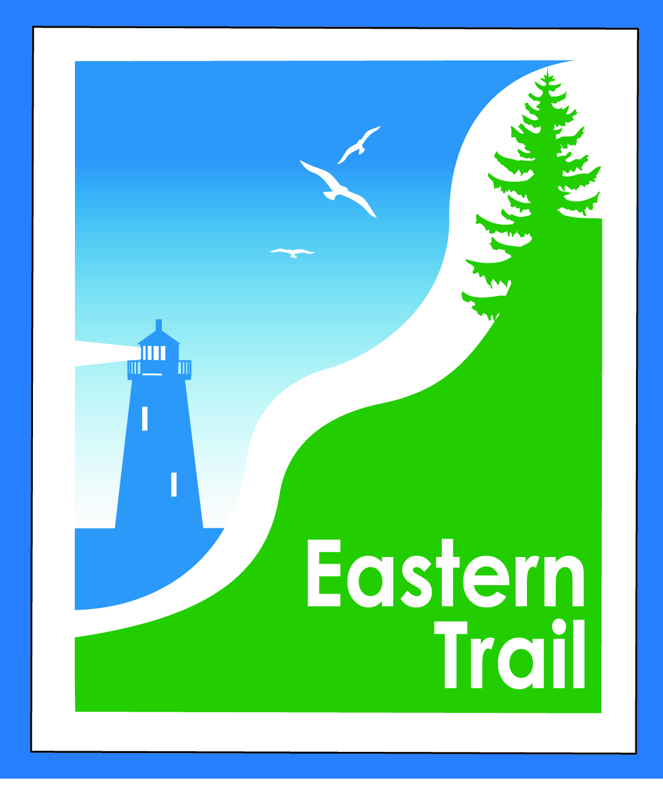

ETMD Board of Directors –Agenda
Kennebunk Town Hall - Third Floor Conference Rm – April 12, 2017 - 8:30 – 10:30 a.m.
- Welcome & Introductions – 2 min
- Cape Arundel Cottage Preserve – Joe Paolini, Rick Licht - 15 min
  - Presentation to Board – Request for spur trail connection to Eastern Trail
- Minutes of March 8, 2017 (to follow) needs vote - 3 min

- Financial – Carole, Val – 10 min
  - March report to follow - needs vote
{{{{
- Operations – 15 min - Carole
  - 2017 trail funding
  - Trustee vacancies
  - Dues Status? All

- Ongoing / Proposed Projects: 40 min
  - Scarborough – 019386.00 Bill, Carole
    - “Gap” Wildlife monitoring project
  - Status Kennebunk – Wells – Marianne, Eric
  - Reports from Municipalities

- Outreach, amenities & Events – 15 min
  - ETA Annual Meeting – Help Us Blaze a Trail South! – May 11th (details to follow)
  - Communications Plan; Ambassador Program
  - Events

- Other Business? – 5 min

- Next Meeting – May 10, 2017

- Adjourn

