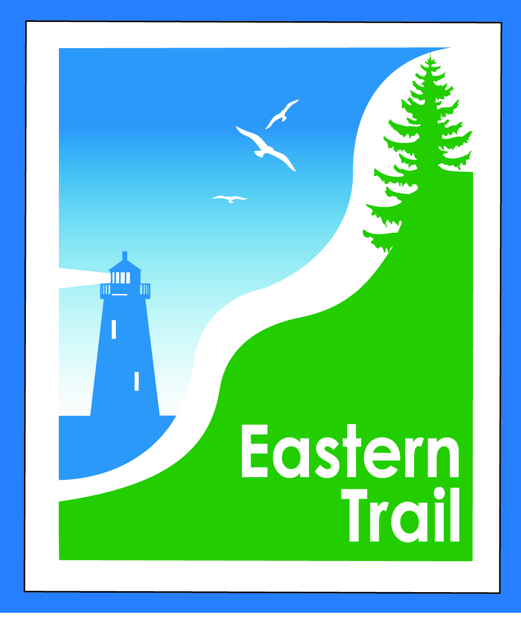

ETMD Board of Directors –Agenda
Kennebunk Town Hall - Third Floor Conference Rm – March 8, 2017 - 8:30 – 10:30 a.m.
- Welcome & Introductions – 2 min
{{{{
- Minutes of January 11, 2016 (included) needs vote - 3 min

- Financial – Carole, Val – 20 min
  - January, February report included - needs vote
  - Proposed projects:
    - Event policy update
    - 2017 Economic Impact Study (update to 2014)
    - John Andrews Memorial
{{{{
- Operations – 25 min - Carole
  - 2017 trail funding
    - PPI help for Wells; pending LOI or grant requests sent or pending
  - General: Surplus signs, trustee vacancies
  - Dues
    - Scarborough received; Wells approved; Request to appear in South Berwick (ETMD position required re Varney St Bridge project)
    - Status from other municipalities?

- Ongoing / Proposed Projects: 40 min
  - Scarborough – 019386.00 Bill, Carole
    - “Gap” Wildlife monitoring project
  - Status Kennebunk – Wells – Marianne, Eric
  - OOB proposed Subdivision – Megan, Val
  - Reports from Municipalities

- Outreach, amenities & Events – 15 min
  - ETA Communications Plan; Ambassador Program
  - Events (covered under Operations)

- Other Business? – 5 min

- Next Meeting – April 12, 2017

- Adjourn

