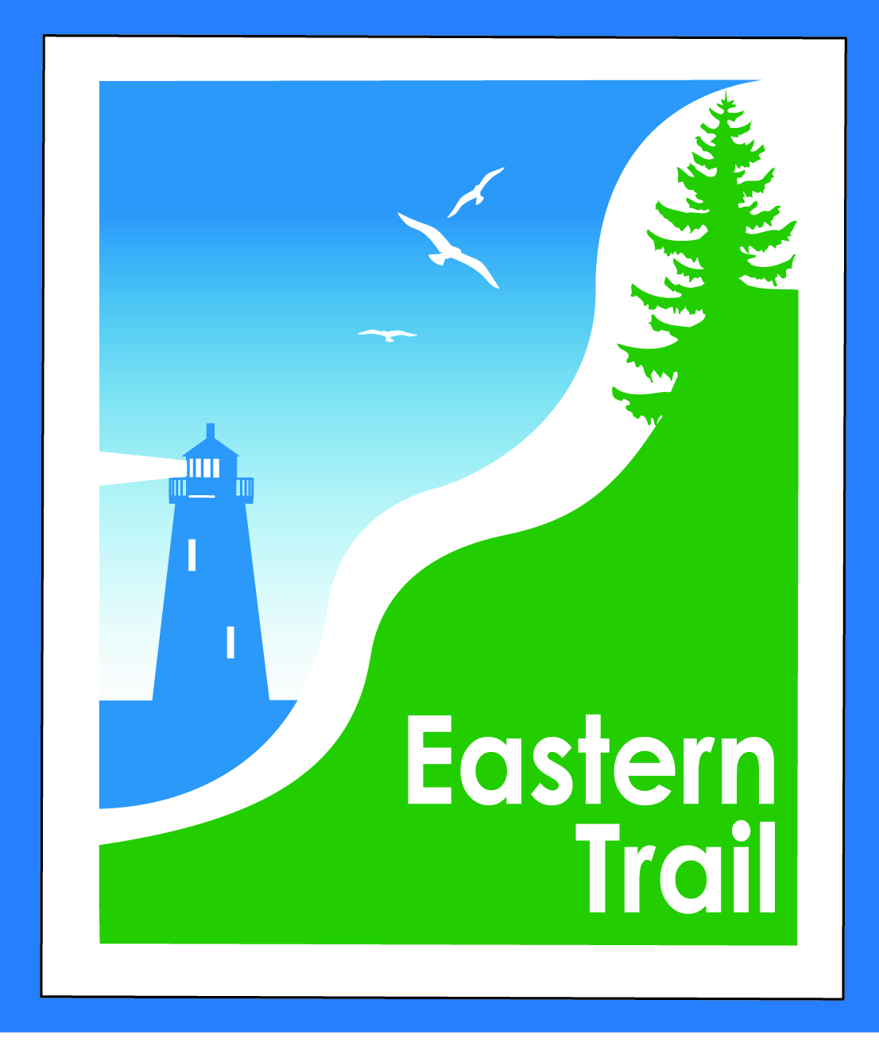

ETMD Board of Directors –Agenda
Kennebunk Town Hall - Third Floor Conference Rm – February 8, 2017 - 8:30 – 10:30 a.m.
- Welcome & Introductions – 2 min

- Minutes of January 11, 2016 - (Tad to send) needs vote - 3 min

- Financial Report – Carole, Val (January - included) – needs vote – 10 min

- Operations – 40 min - Carole
  - Dues
    - Scarborough received
    - Request to appear:
      - Wells (2/15)
      - South Berwick (March tbd) (ETMD needs to review Varney St bridge position)
    - Status from other municipalities?
  - 2017 trail funding
    - LOI or grant requests sent or pending

- Ongoing / Proposed Projects: 45 min
  - Scarborough – 019386.00 Bill, Carole
  - Biddeford-Saco Gap – Greg, Bob
  - Status Kennebunk – Wells – Marianne, Eric
  - Reports from Municipalities
    - Arundel – Letter sent to York Co Sheriff on 1/19

- Outreach, amenities & Events – 15 min
  - ETA Communications Plan
  - ETA Trail Ambassador Program
  - ETA Events
  - Other Events

- Other Business? – 5 min

- Next Meeting – March 8, 2017

- Adjourn

