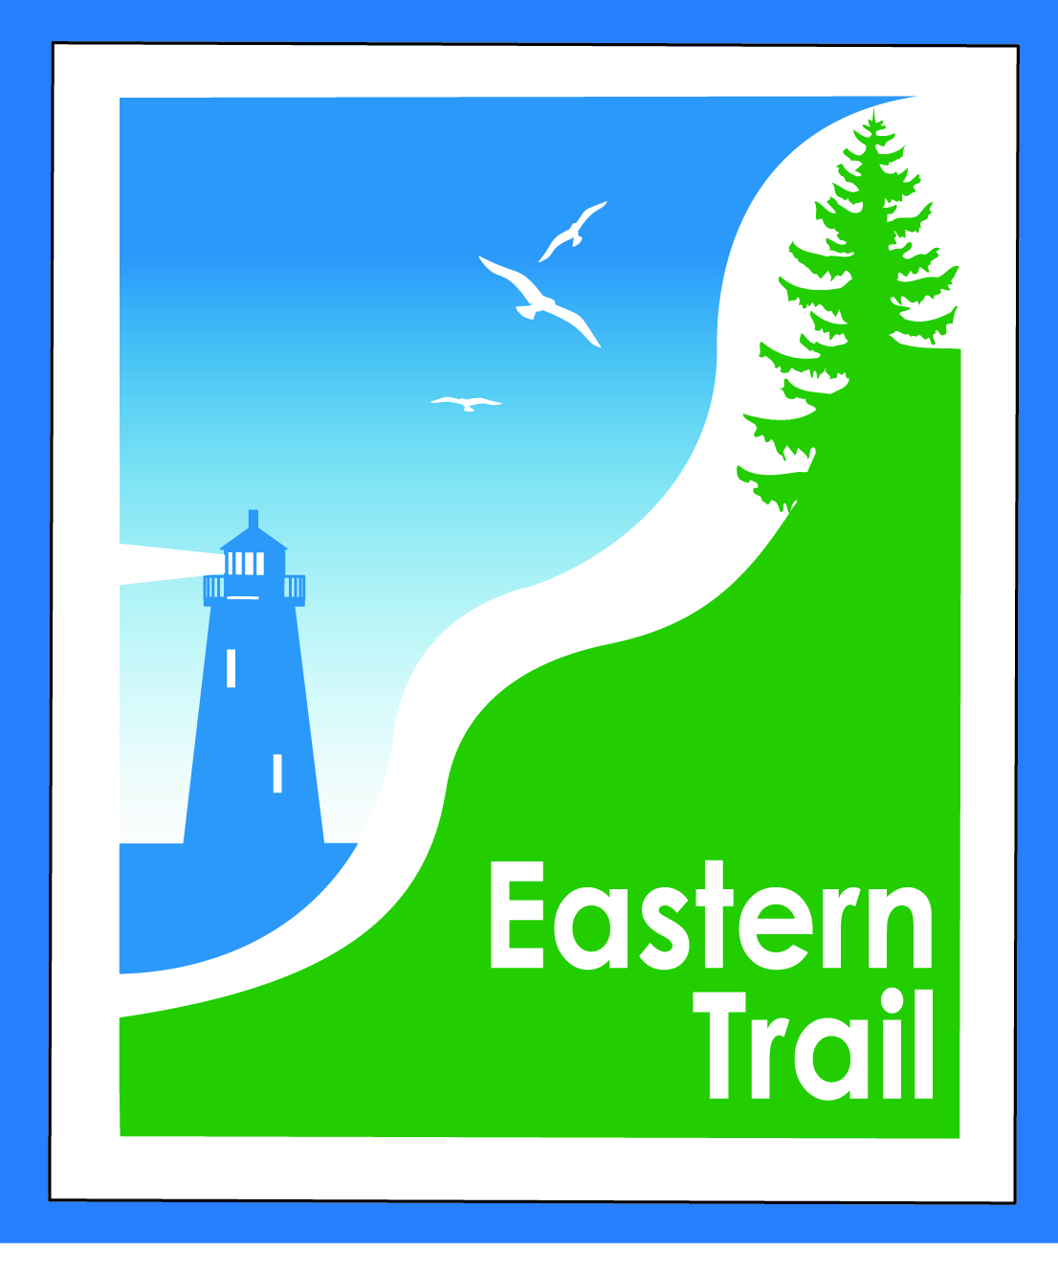

ETMD Board of Directors – Agenda
Kennebunk Town Hall - Third Floor Conference Rm – January 13, 2016 - 8:30 – 10:30 a.m.

- Introductions – 3 min

- Minutes of December 9, 2015 – included – needs vote - 2 min

- Financial Priorities – 10 min
- Review of current financial report – Val/Carole – included – needs vote
- Initial 2016 request for dues - Marianne/Carole
  - Schedule visits to town managers and/or budget committees – Marianne/Carole
- Status 990 and RHR audit – Marianne/Carole

- ETMD Priorities - 100 min
  - Updates & next steps re 1/08/16 Unitil CLA meeting – All
  - Kennebunk, Wells, South Berwick – next steps = funding options - Municipal reps & officials
  - North Berwick – next steps = outreach
    - Dwayne Morin – Marianne, Carole
    - Pratt & Whitney, Hussey – Marianne, Carole & two ETA/ETMD reps
  - Reports from Executive Director and Municipalities (includes new projects, existing trail conditions, maintenance concerns)
  - Future ET planning – Carole – 3 min
      - Office space and storage update
      - Outreach & funding
        - Update on directional trail signage and ETA outreach campaign
- Other Business - 2 min – issues? Concerns

- Next Meeting – February 10, 2016

- Adjourn

