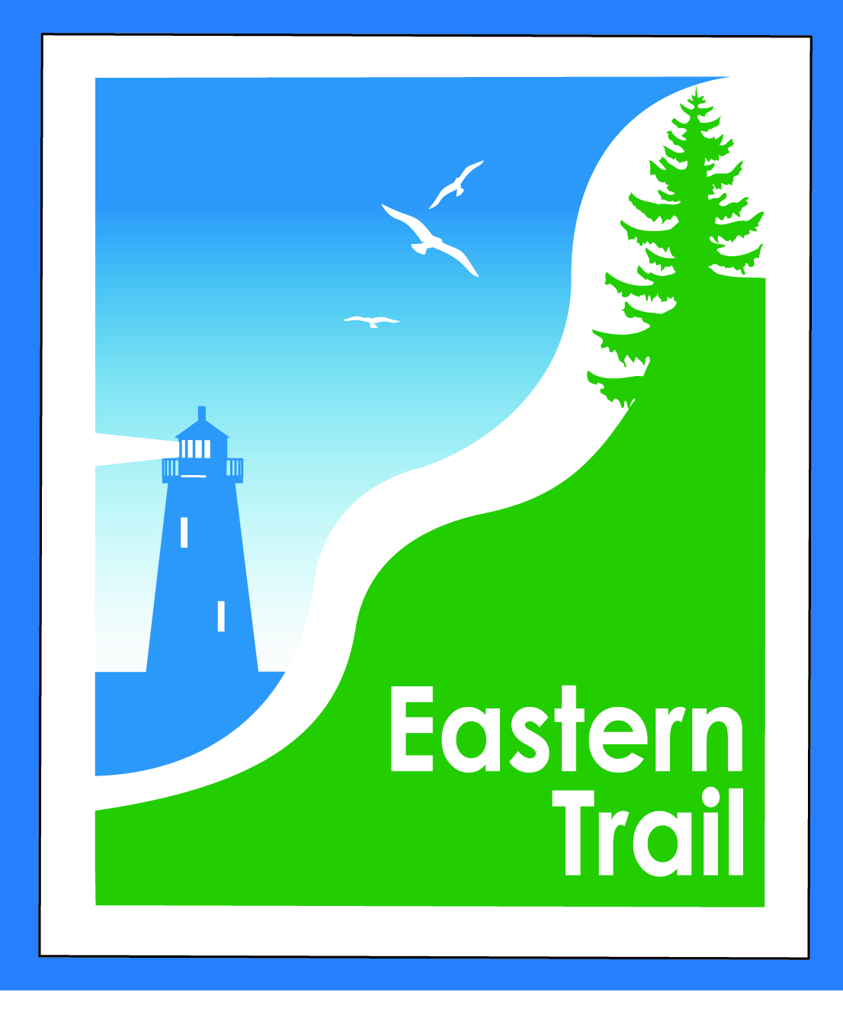

ETMD Board of Directors
Minutes
January 10, 2018
In attendance:
- Officers: Eric Labelle, VP; Bob Hamblen, Secretary
- Trustees: Marianne Goodine, Wells; Joe Yuhas, ETA; Tad Redway, Arundel; Val Camire, OOB; Greg Tansley, Biddeford.
- Staff: Carole Brush, Executive Director
- Welcome & Introductions at 8:36 a.m.

- ETMD EVENT POLICY DISCUSSION – Larry Meade, OOB town manager, called in at 8:47, to express concerns about fee increase for the August 2018 triathlon hosted by OOB. Eric: ETMD is trying to be self sustaining, and imposed fee increase prior to the Ironman registration period starting. Larry: understand that goal. The Ironman is only event of that magnitude. Eric: will need to maintain the Trail after the event is over. Larry: fee appears to target the Ironman event. Board could perhaps have contacted Ironman earlier. I don’t know if it’s a deal breaker for Ironman. It’s a positive activity for OOB. We don’t charge what is being contemplated by ETMD. Not opposed to a fee, but it’s been enacted without sufficient interaction with biggest user. Eric: typically an event promoter should approach the ETMD for a use permit. Larry: would ask that ETMD rescind the $20,000 fee for this year, and talk with Ironman about other arrangements. Eric: there is room for partnering on a reasonable solution. Larry: OOB is strong supporter of the ET, happy it goes through OOB, want to see it thrive. Tad: would you help us talk with Ironman? Larry: yes. $315 registration fee, and they’re hoping for 2,000 registrants. Tad: you can’t focus on Ironman alone. Where did the $10/head come from? Reality is towns already maintain the Trail. Tad: it’s one of several solutions for increasing revenue. We have members towns that don’t pay fees. Eric: should host towns of event get a cut from fees? Carole: another group wanted to hold an event, a compromise of $5/participant plus a % of proceeds was reached. About 350 participants, in Kennebunk. Greg: some legitimacy in having a standardized fee, but where did the $10 come from. Perhaps a sliding scale makes more sense. Eric: from a manager’s perspective, we’re giving ETMD $5,000 a year, and we’re still asking our DPW to maintain the trail. Tad: back in 2001, the managers wanted this organization. But few remain from back then. Greg: not as much accountability for the ET as there, for example, for trails in Portland. Decision was made on this in Sept. 2017, but towns not made aware until January. Carole: had Ironman reached out they’d have heard that. The onus could have been on us to communicate that. Spoke with Jason Webber, OOB, got contact info for Ironman, didn’t hear back. In December the e-mail went out, heard back in January. What is a reasonable compromise? Greg: what is a justifiable cost? In Biddeford a flat fee is charged, whether 100 or 500 runners. Eric: we should figure out how to partner with Ironman; what’s good for them is good for us. Greg: what is a rational fee? Tad: should require ET logo appear on every event’s literature, or website. 80-90% of registrants are signed up already. Greg: Larry suggested that town is not required to pay annual dues, resonated with me. Tad: if we lose too many members, ETMD would dissolve. Joe: state has acknowledged success of Trail. Tad would be willing to meet with Larry, along with Carole and Val. Perhaps Bill should be included. Tad: what town has a right to limit ET events within their borders, as Scarborough has done for Ironman’s route? Impacts on Saco? Part of bike route ventures into Saco. So, maybe Bob H makes sense to include in meeting with Jason Webber, OOB parks and rec, and with Ironman. Greg: what is actual expense to either Trail, or to towns? Bob: are towns paid an honorarium, or costs covered in any way? What costs of towns are covered by Ironman, if any? Marianne: $1 per registrant for 2018 is fair. How many hours of Carole’s go into this? About ten to twenty. Tad: no less than the Maine Lighthouse Ride, we need to realize some revenue to keep the Trail going. Eric: we should figure out how to partner with them in other ways: a table at their event, their logo on our stuff, our logo on theirs. Greg: if they know ahead of time, don’t think they’ll have a problem with $5 or $10 toward ET. Val: participants are so appreciative. Plan on meeting on Jan. 16, afternoon, will confirm after this meeting. At OOB town hall, will check with Larry as to availability. 1:00 p.m. tentatively. UPDATE: Meeting confirmed with OOB and ETMD, waiting to hear back from Ironman. Carole reaching out to Bill Reichl as well this afternoon.

- Minutes of December 13, 2017 -- motion by Bob, seconded by Tad to accept, unanimous.

- Financial – 10 min
  - December report (included) - needs vote – Carole, Val – Joe moves to accept, seconded by Tad, and so voted, unanimous.
  - Dues Status – draft letter coming but not yet available. Carole will distribute via e-mail over the weekend. Will address the movement south, working with Unitil, working on Kennebunk-Wells sections. Continued fundraising for Close the Gap in SoPo – Scarborough.
    - Reports from municipalities on budget deadlines – Biddeford would like letter by 1/25. Any other deadlines? Apparently not.
- Operations – 25 min
  - Update Hallczuk legal actions – Tad, Carole – delayed to April. Hallczuk showed but his attorney did not, appointed an alternate who requested a continuance. Hallczuk is ordered to not be on the Trail, or his dog(s), and can be arrested if that is violated.
  - Review / approve proposed Connection Agreement – Carole – Arundel-Kennebunkport Cottage Preserve, Tim Murphy has drafted, they have yet to see it. Tad: nine of cottages have just frozen up. Need an officer’s signature on the Connection Agreement – also need a notary. One time, $5,000 fee. Eric will sign. Carole: 2 other groups will be connecting to Trail. Arundel Conservation Trust will be looking to connect via a spur trail from new town hall site, about a .25 mile trail. Wells, Maine Coast Heritage Trust, proposing to acquire the Getchell Pasture, 125 acres, 4,000 feet of frontage along the ET corridor.
- Ongoing / Proposed Projects: 25 min
  - Scarborough – 019386.00 Carole – has thanked Jim Tasse and BCM for getting us a meeting with MDOT Commissioner. Project is up to $4.1 million. South Portland meeting with Hale this week, town and State do not want to “take” the land, find an agreement. Commissioner Bernhardt said continue your fundraising. In December $152,000 came in. DOT is behind the project, why taking so long? Roughly $500,000 will close the gap. SoPo and Scarborough should see agreement some time in January. Scarborough met on Friday, where do they go from here? Will be fewer committee meetings. Design will go forward by HNTB. Scarborough will continue in LAP role. Presenting to SoPo Council on 1/17, an update, thanks for support. Rob Liscord, SoPo resident, ETA member will join Carole at the meeting.
  - Status Kennebunk – Wells – Marianne, Eric, Carole – Carole is working on a grant application to Sewall Foundation, with input from both towns. Goal to complete 4 miles more of survey work, then move forward with permitting for whole 10 miles. Estimated cost roughly $280k. App to be submitted on Friday. Need town buy-in on amount sought. Update: ask will be for $100,000
  - Reports from Municipalities. Carole met with So. Berwick last night, good discussion with selectmen. Workshop to be scheduled late January, early February with Carole and South Berwick to discuss in more detail. Provided map and write-up on progress to date, and plans for seeking funding. Consistently delivering the message that after SoPo – Scarborough, south is the next push. Eric: periodic complaints, snowmobiles on the Trail. A particular landowner pursuing this, Kennebunk could help address this, they say. Kennebunk does not patrol the Trail, don’t clear snow. No snowmobile club in town to approach.

- Outreach & Events – 15 min – Carole, Jim
  - EIS – Jim Bucar working on Economic Impact Study; coming along well; counters on all off road sections.
  - Upcoming ETA / ETMD events -- ETA has several events planned. Gala at Camp Ketcha, Scarborough, scheduled for April 7. Carole will send along schedule of additional events. Nancy now more hours, and Jen, new volunteer/event coordinator providing a big boost. Total of 17 hours per week additional staff time between them.

- Other Business? – Carole: a request -- ETA has put photos and thumbnail sketch of board members on website. Like to do same with ETMD. Thumbnail sketch and a photo. Board receptive to concept.

- Next Meeting – February 14, 2018

- Adjourn

