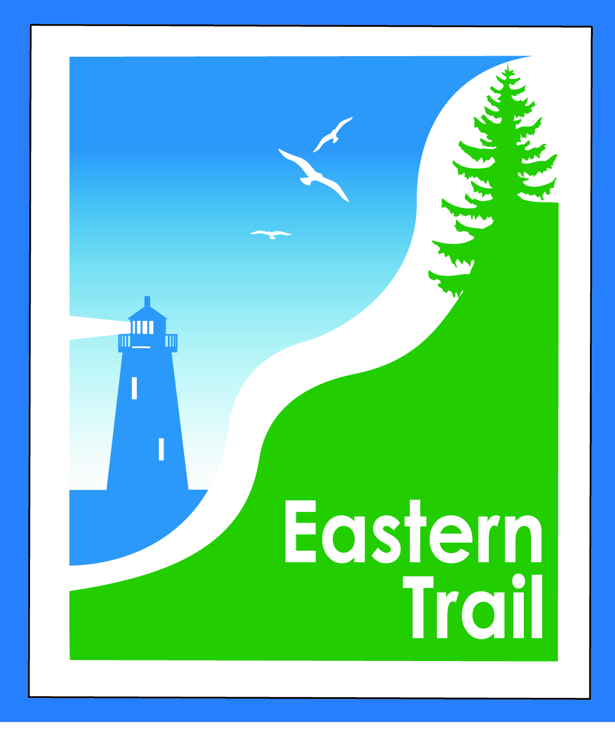

ETMD Board of Directors Agenda
Kennebunk Town Hall - Third Floor Conference Rm – January 9, 2019 - 8:30 – 10:30 a.m.

- Welcome & Introductions – 5 min
- Minutes of November 14, 2018 – attached - needs vote - 2 min (Note – no December meeting)

- Financial – 8 min
  - November/December report – attached - needs vote – Carole, Val
  - Dues status - Carole
- Operations – 45 min
  - IronMan counter offer attached - needs discussion & vote – All
  - Connection Updates – Tad, Carole
  - ACT changes – status
- Ongoing / Proposed Projects - 45 min (Summary to follow)
  - Close the Gap - Scarborough – 019386.00 – Bill, Carole
  - Blazing the Trail South - Kennebunk – South Berwick –- Carole, Marianne, Bryan
  - Action Items:
  - Kennebunk-Wells: Proceed with Wells survey, meet with both towns for design discussion (CB)
  - North Berwick: Find solution to sanitary district concerns & set up meeting (TR, GT, CB)
  - South Berwick: Respond to TIF? (TR); provide existing bridge costs & spans (CB)
  - Over the River – Saco-Biddeford connection – Greg, Ryan, Carole
  - Action item: Set up meeting with Pan Am (Kevin Sutherland)
  - Reports from Municipalities

- Outreach & Events – 5 min - Carole, Jim, Joe
  - Upcoming ETA / ETMD events – Carole, Joe

- Other Business? – 5 min

- Next Meeting – February 13, 2019

- Adjourn

